高雄市114年度第44屆國民中小學科學園遊會 高雄市鳳山區中正國小
Kaohsiung Primary and Junior High Schools Science Lawn Party
Kaohsiung Fengshan District Zhongzheng Elementary School

摸摸渣渣
The pores of coffee grounds

指導教師：郭怜延、范銘仁、陳偉庭、張政元
學生：洪唯誠、顏呈恩、侯昀儒、莊喬羽、洪唯碩、陳子庭
施竣凱、羅靖雯、蘇逸羚、邱莘嵐、林妤庭
魏妍容、張聿緹、潘和、蕭以晴、吳宇桓
楊宇宸、方宥凱、田丞妤、田丞妡、李亞娍
李冠妍、郭宸羽、鄭棋成、郭宸菲、郭芊妤、吳親澤

- 活動主旨Activity Objectives
本活動以日常生活中常見的「咖啡渣」為主題，設計一系列趣味性與科學性兼具的闖關活動，讓學生在動手操作的過程中，體驗科學原理如何與生活材料結合。透過三個關卡，學生將觀察咖啡渣的吸油性、除臭性與清潔效果，進一步了解其與孔隙結構的關聯，並學習如何將廢棄物資源化，培養環境永續的意識。活動除了強調動手實驗與觀察，也融入科學探究方法，鼓勵學生發問、比較與討論，讓他們能將科學知識與生活經驗相連結。期望學生在參與過程中，不僅能獲得有趣的學習體驗，也能激發對環境保護與資源再利用的重視，進一步思考如何將科學應用於日常生活。
This activity takes the familiar material of “coffee grounds” as its theme, designing a series of engaging and science-oriented challenge stations. Through hands-on experiments, students will experience how scientific principles can be applied using everyday materials. Across three stages, students will explore the oil-absorbing, deodorizing, and cleaning properties of coffee grounds, gaining a deeper understanding of their relationship to porous structures. They will also learn how waste can be transformed into a resource, fostering awareness of environmental sustainability.
The activity emphasizes both experimentation and observation, while also incorporating the methods of scientific inquiry. Students are encouraged to ask questions, make comparisons, and engage in discussions, helping them connect scientific knowledge with real-life experiences. It is hoped that through participation, students will not only enjoy a fun and meaningful learning experience but also develop a stronger appreciation for environmental protection and resource reuse, inspiring them to think about how science can be applied in everyday life..

- 名詞解釋Definition of terms
  - 孔隙：Pores
物質中存在許多細小的空隙，能儲存或通過水分、氣體或其他分子。咖啡渣的孔隙讓它具有良好的吸附與過濾功能。
Within substances, there are numerous tiny pores that can store or allow the passage of water, gases, or other molecules. The porous structure of coffee grounds gives them excellent adsorption and filtration functions.
  - 吸附作用：Adsorption
固體表面的微小空隙或凹凸不平結構，能夠抓住並保留分子或離子。例如咖啡渣能吸附異味分子，達到除臭效果。
The tiny pores or uneven structures on a solid surface can capture and retain molecules or ions. For example, coffee grounds can adsorb odor molecules, achieving a deodorizing effect.
  - 過濾：Filtration
利用物質之間孔隙大小的差異，讓液體或氣體通過，而阻擋較大的顆粒。咖啡渣在清潔或吸附油脂時，就展現了過濾的效果。
By making use of differences in pore size between substances, liquids or gases can pass through while larger particles are blocked. When coffee grounds are used for cleaning or absorbing grease, they demonstrate a filtering effect.
- 材料準備
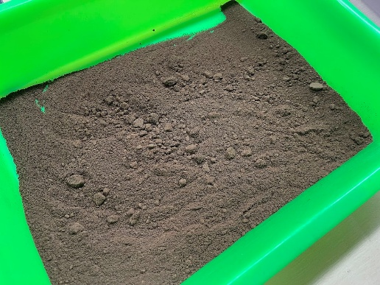 | 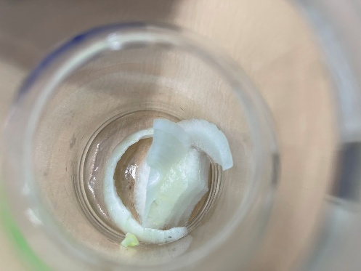
盆裝咖啡渣 | 切塊洋蔥
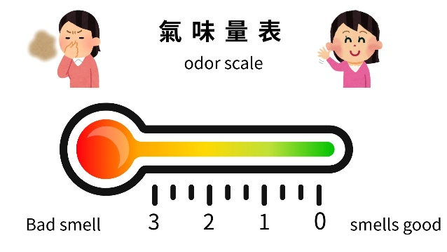 | 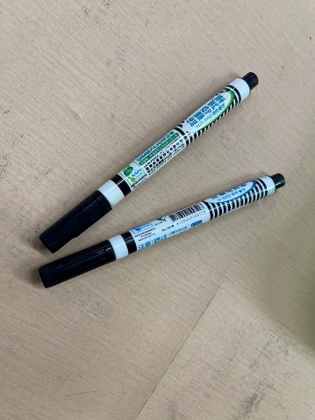
自製氣味量表 | 油性奇異筆
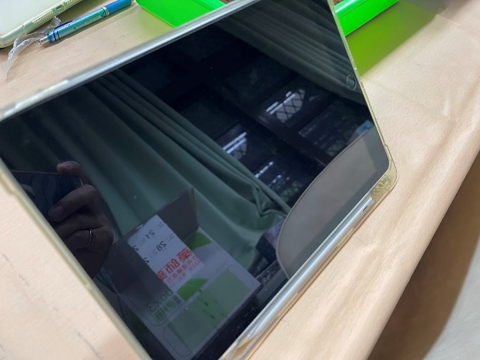 | 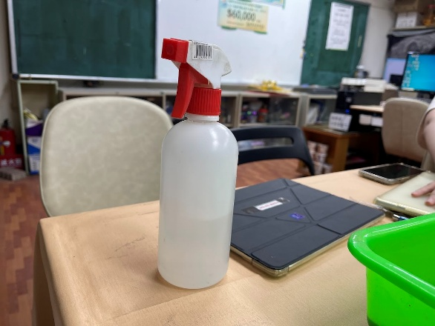
平板電腦 | 噴霧瓶

- 關卡活動Challenge activity
  - 聞聞渣渣：洋蔥脫味任務Smell the Grounds
準備兩個密封容器，一個放入咖啡渣，另一個保持空白，再同時放入切好的洋蔥片。經過一段時間後打開比較，觀察氣味是否減弱。
請來賓在自製氣味量表中用手指指出無咖啡渣與有咖啡渣的氣味程度。(如圖一)
學生可透過此次實驗了解咖啡渣的除臭效果。
Prepare two sealed containers: place coffee grounds in one, and leave the other empty. Put sliced onions into both containers at the same time. After some time, open them and compare whether the odor has weakened.
Invite participants to use a self-made odor scale, pointing with their fingers to indicate the odor levels of the container without coffee grounds and the one with coffee grounds.
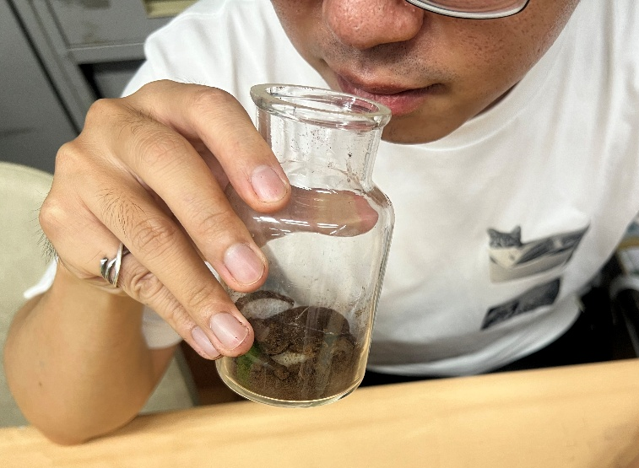
圖一

  - 洗洗渣渣：磨砂清潔實測Wash with Grounds
請學生將咖啡渣裝盆，並用油性奇異筆在來賓手背畫上兩條一樣的線，一條用手直接摩擦，另一條加上咖啡渣一起摩擦，兩邊都搓 30 秒，再用清水清洗。比較，哪一邊比較乾淨。(如圖二)
觀察咖啡渣在吸附油脂與摩擦清潔上的差異。
Ask students to place coffee grounds in a container. Using an oil-based marker, draw two identical lines on the back of a participant’s hand. Rub one line directly with the hand, and rub the other line together with coffee grounds, both for 30 seconds. Then rinse with clean water. Compare which side is cleaner.
Observe the difference in how coffee grounds absorb grease and enhance cleaning through friction.
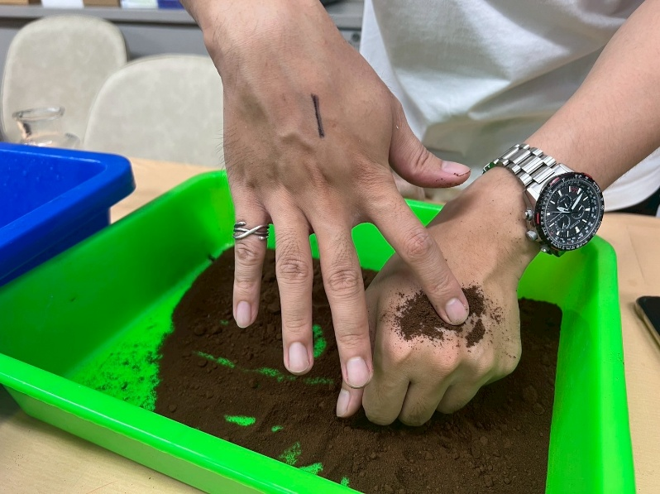
圖二

  - 答答渣渣：科學補給站Answer with Grounds
學生完成前兩關後，利用數位線上方式進行知識補充小測驗，題目內容涵蓋「孔隙」、「吸附作用」、「咖啡渣應用」等科學概念，讓來賓在遊戲中鞏固所學知識。(如圖三)
After completing the first two stations, students will take a short digital quiz to reinforce their knowledge. The questions will cover scientific concepts such as “pores,” “adsorption,” and “applications of coffee grounds,” allowing participants to consolidate what they have learned through an engaging game format.
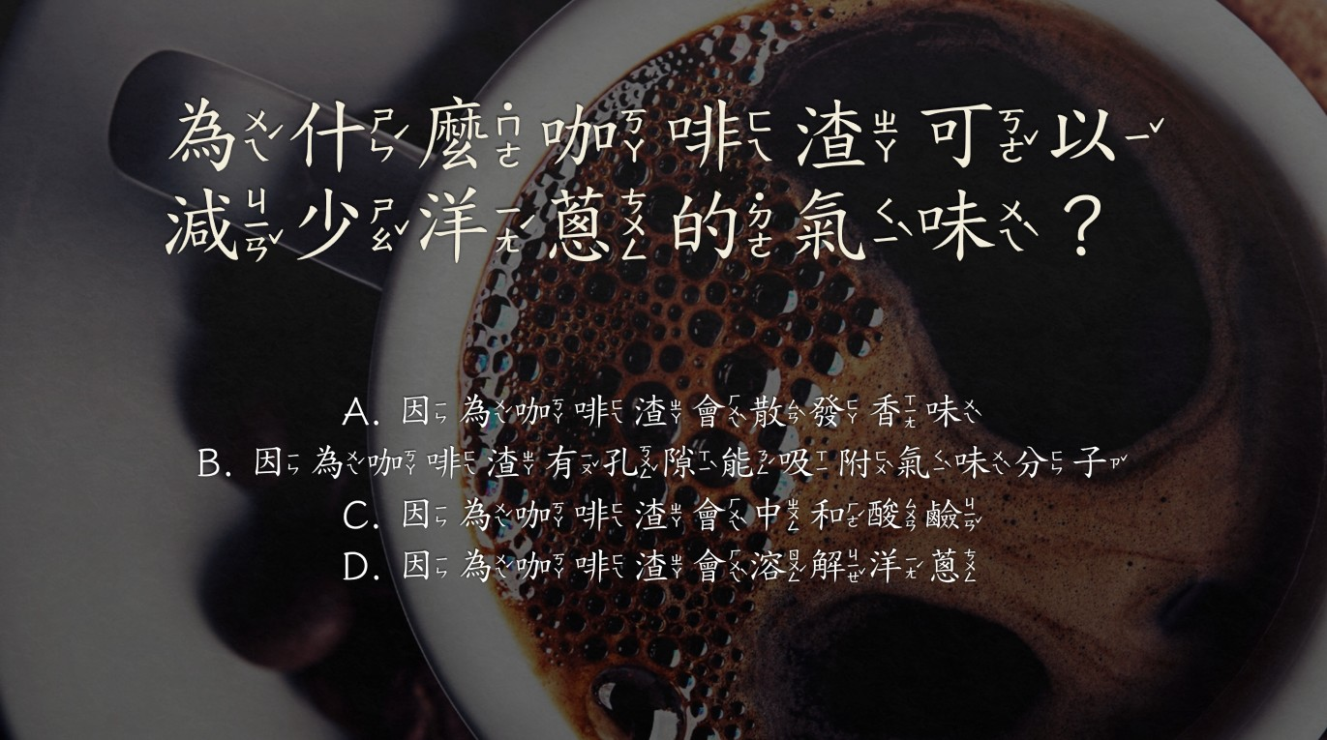
圖三

- 結果與討論Discussion and Conclusion
學生將可在此活動中，發現：
  - 咖啡渣的特性：學生將了解到放有咖啡渣的容器異味減輕，顯示咖啡渣孔隙能吸附並捕捉氣味分子。而咖啡渣能有效去除油污，不僅因為孔隙能吸附油脂，也因為顆粒產生磨砂摩擦效果。
  - 物理學的基本概念：透過觀察和實驗，學生會學到物質表面或孔隙可以抓住其他分子，並將其黏附在表面。
  - 科學探究能力：透過實際操作和觀察，學生將培養批判性思維和問題解決能力。
  - 永續思維：學生體會「垃圾變資源」的概念。咖啡渣雖是廢棄物，但透過除臭、清潔或土壤改良等用途，能延長其價值，減少浪費，符合永續發展的理念。
期許這些學習成果不僅能增強他們的科學素養，還能激發對學習的興趣與熱情。
Through this activity, students will discover:
      - Characteristics of coffee grounds: Students will observe that containers with coffee grounds have reduced odors, showing that the pores in coffee grounds can adsorb and trap odor molecules. Coffee grounds can also effectively remove grease, not only because the pores absorb oils but also because the particles provide a scrubbing effect through friction.
      - Basic concepts of physics: By observing and experimenting, students will learn that the surface or pores of a substance can capture other molecules and adhere them to its surface.
      - Scientific inquiry skills: Through hands-on practice and observation, students will develop critical thinking and problem-solving abilities.
      - Sustainability mindset: Students will experience the concept of “turning waste into resources.” Although coffee grounds are waste, their applications in deodorizing, cleaning, or soil improvement can extend their value, reduce waste, and align with sustainable development principles.
It is hoped that these learning outcomes will not only enhance their scientific literacy but also spark greater interest and enthusiasm for learning.

- 未來貢獻Future contribution
本活動不僅讓學生認識咖啡渣的科學原理，更引導他們思考「資源再利用」與「永續發展」的重要性。咖啡渣雖是日常廢棄物，但透過科學應用，可在除臭、清潔與農業改良等方面發揮價值，呼應 SDGs 12 ─負責任的消費與生產。此外，學生能從中學習觀察、比較與驗證，培養科學探究能力，並進一步思考如何將其他生活廢棄物（如果皮、蛋殼）轉化為資源，減少環境負擔。未來，學生可延伸研究咖啡渣在環境工程、循環經濟中的應用，將小小實驗轉化為更廣泛的永續實踐。
This activity not only helps students understand the scientific principles behind coffee grounds but also guides them to reflect on the importance of resource reuse and sustainable development. Although coffee grounds are everyday waste, through scientific applications they can be valuable in deodorization, cleaning, and agricultural improvement, aligning with SDGs 12 – Responsible Consumption and Production.
In addition, students will practice observing, comparing, and verifying, which nurtures their scientific inquiry skills. They will also be encouraged to think about how other household waste materials (such as fruit peels and eggshells) can be transformed into resources, reducing environmental burdens. Looking ahead, students may extend their research into the applications of coffee grounds in environmental engineering and the circular economy, turning small-scale experiments into broader practices for sustainability.

- 參考文獻
1.黎冠廷, & 林宸緯.（2024）. 叱「渣」風雲-廚房廢渣再利用. 中小學科學展覽會. 取自 https://twsf.ntsec.gov.tw/activity/race-1/63/pdf/NPHSF2023-082912.pdf?0.6640281137079
2.農業部農業知識入口網.（2021）. 果實構造. 取自 https://kmweb.moa.gov.tw/subject/subject.php?id=45603
3.Beuchat, L. R. (1983). Influence of water activity on growth, metabolic activities, and survival of yeasts and molds. Journal of Food Protection, 46(2), 135-141.

