噗噗高升
Be promoted to higher and higher
高雄市岡山區岡山國小
指導老師：孔慧鈴、黃重仁
鄧詠淳、邱汶津

一、旨趣：
在球類運動中，經常可看到球的運動路徑不是直線，而是會轉彎。例如足球的香蕉球、棒球的曲球、乒乓球的抽球等等。這些現象都是因為除了往前運動之外，又快速的旋轉所造成，此現象被稱為「馬格努斯效應（Magnus effect）」。以下利用吸管吹保麗龍球上樓梯的遊戲，可以呈現有趣的馬格努斯效應。
In ball sports, it is often seen that the path of the ball is not straight, but turns. For example, the banana ball in football, the curve ball in baseball, the draw ball in table tennis, etc. These phenomena are caused by rapid rotation in addition to forward motion. This phenomenon is called the "Magnus effect." The following game uses a straw to blow a styrofoam ball up the stairs to create an interesting Magnus effect.

二、材料：
壓舌板製作的障礙樓梯、粗/細吸管、保麗龍球。
Barrier stairs made from tongue depressors, thick/thin straws, styrofoam balls.

三、活動流程：
（一）闖關者事先觀看説明影片，了解遊戲規則與科學原理。
（二）抽取關卡卡片，選擇粗或細的吸管。
（三）將保麗龍球沿著樓梯往上吹，直到吹進球籃就成功過關，如果在十秒內完成可獲得獎品一份。
(1) Players must watch the explanatory video in advance to understand the rules and scientific principles of the game.
(2) Extract the level card and choose a thick or thin straw.
(3) Blow the styrofoam ball up the stairs until it hits the basket and you will successfully pass the level. If you complete it within ten seconds, you will get a prize.

四、過關標準：
將保麗龍球沿著樓梯吹進球籃即可過關，途中掉落必須重頭開始。
Blow the styrofoam ball down the stairs into the basket to pass the level. If it falls on the way, you have to start over.

五、原理：
牛頓在1672年的劍橋學院（Cambridge college）觀看了網球比賽後，發現並推論了網球在快速旋轉時會偏移的現象與原因。相隔一百多年後，1852年德國物理學家馬格努斯（Magnus）說明了這種效應，而被稱為「馬格努斯效應」。
馬格努斯效應說明一個球狀物體（或圓柱體），如果快速旋轉，空氣（或其他流體）流通經過球體時，球體上下的空氣流速會產生壓力差，而產生向上的作用力。以圖八為例，球體往右運動，並以逆時針方向旋轉，則在球體上方由於空氣流動方向與球體旋轉方向相同，使得空氣流速較快，並使得氣流往下偏流。反之球體下面，空氣流動方向與球體旋轉方向相反，使空氣流速較慢，並傾向於保持直線流動。因此由於球體上方的空氣流速快（壓力小）、下方流速慢（壓力大），形成了壓力差，而產生往上的作用力。
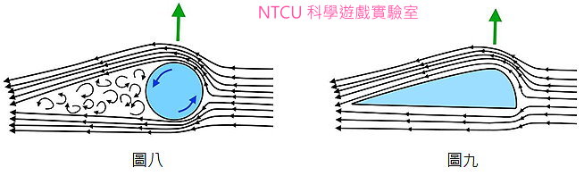
After watching a tennis match at Cambridge college in 1672, Newton discovered and deduced the phenomenon and reasons why tennis balls deflect when they spin rapidly. More than a hundred years later, in 1852, the German physicist Magnus explained this effect, which was called the "Magnus effect."
The Magnus effect explains that if a spherical object (or cylinder) rotates rapidly and air (or other fluid) flows through the sphere, the air flow velocity above and below the sphere will produce a pressure difference, which will produce an upward force. Taking Figure 8 as an example, the sphere moves to the right and rotates counterclockwise. The air flow above the sphere is in the same direction as the rotation of the sphere, making the air flow faster and deflecting the air flow downward. On the contrary, under the sphere, the air flow direction is opposite to the rotation direction of the sphere, making the air flow slower and tending to maintain a straight flow. Therefore, because the air flow speed above the sphere is fast (low pressure) and the flow speed below the sphere is slow (high pressure), a pressure difference is formed, which generates an upward force.

