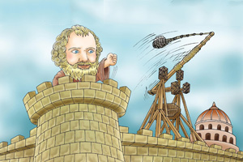
投石器~攻城吧！
Attack the city by the Catapult
高雄市苓雅區福東國小
指導老師:林麗娟、陳秀婷、彭聲聞、陳柏村、Ady
實習教師:李珈慈、謝欣芷

- 前言:大約兩千三百年前，有位猶如神話中百手巨人的科學家，以智慧及勇氣阻擋了敵軍的進攻，他就是赫赫有名的｢阿基米德｣。他最為人所知的防守武器發明便是投石器、吊船器與反光鏡燒船，其中，投石器更是後世戰爭中經常出現的強力武裝，其所應用的原理為何呢？讓我們一起來動手做做看吧！
1. Introduction: Approximately 2,300 years ago, there was lived a scientist who resembled the mythical giant with a hundred hands. He blocked the enemy's attack with his wisdom and courage. He was the famous Archimedes. His most renowned inventions for defense included catapults, cranes, and reflective devices used to set enemy ships on fire. Among them, catapults are powerful weapons that often appear in later wars. What are the principles used in them? Let’s try it out together!

二、目的: 阿基米德曾誇口說：「給我一個支點，我就能移動地球。」他充分運用槓桿原理，製作各種器械，在彈力式投石器當中，如何配置支點、施力臂及抗力臂的位置，以及彈力的大小，來達到最高投石效能？我們要讓孩子實際動手做做看，體驗千年前古人的智慧結晶。
2. Purpose: Archimedes once boasted: "Give me a place to stand on, and I will move the Earth." He made full use of the lever principle to make various When it comes to elastic catapults, how should we position the fulcrum, the force-applying arm, the resisting arm, and determine the magnitude of elastic force to achieve maximum slinging efficiency? Our goal is to engage children in hands-on activities and let them experience the wisdom of ancient civilizations from thousands of years ago."

三、實驗器材:
A.冰棒棍簡易版(Simple version)：冰棒棍(Popsicle sticks)、橡皮筋(rubber bands)、寶特瓶蓋(PET bottle caps)、泡棉膠(foam glue)、衛生紙(toilet paper)。
B.竹筷角錐版(Pyramid version)：竹筷(Bamboo chopsticks)、橡皮筋(rubber bands)、塑膠湯匙(plastic spoons)、膠帶(tape)、A4紙(A4 paper)。

四、操作活動:
A.冰棒棍簡易版(Simple version)
步驟一：將兩枝冰棒棍的一端用橡皮筋纏緊。  Step 1: Tighten one end of the two popsicle sticks with a rubber band. | 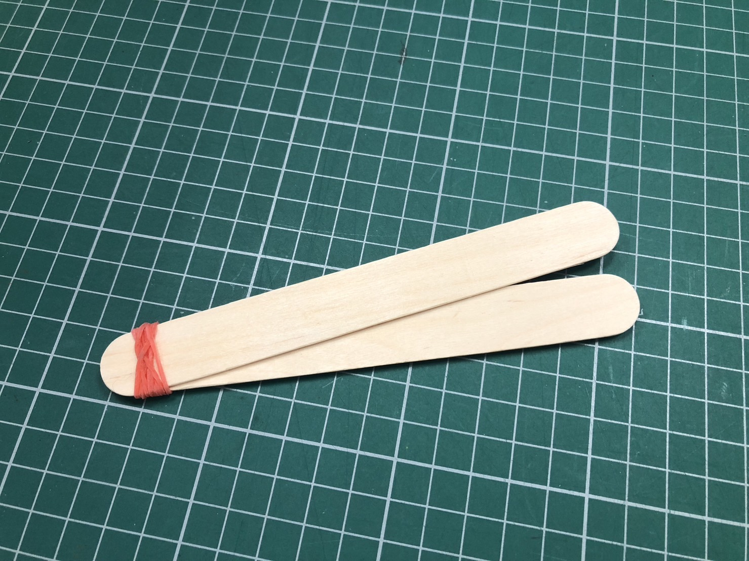 | 步驟二：將一個瓶蓋黏在冰棒棍的另一端。  Step 2: Glue a bottle cap to the other end of the popsicle stick. | 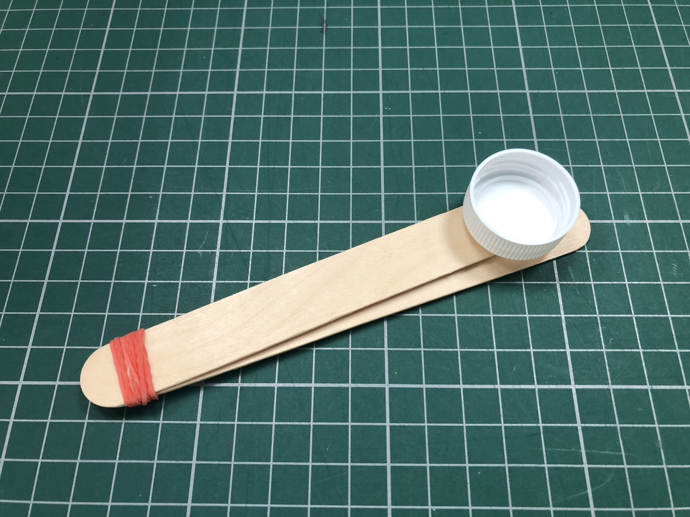
步驟三：取六枝冰棒棍，用橡皮筋將兩端纏緊。  Step 3: Take six popsicle sticks and tie both ends tightly with rubber bands. | 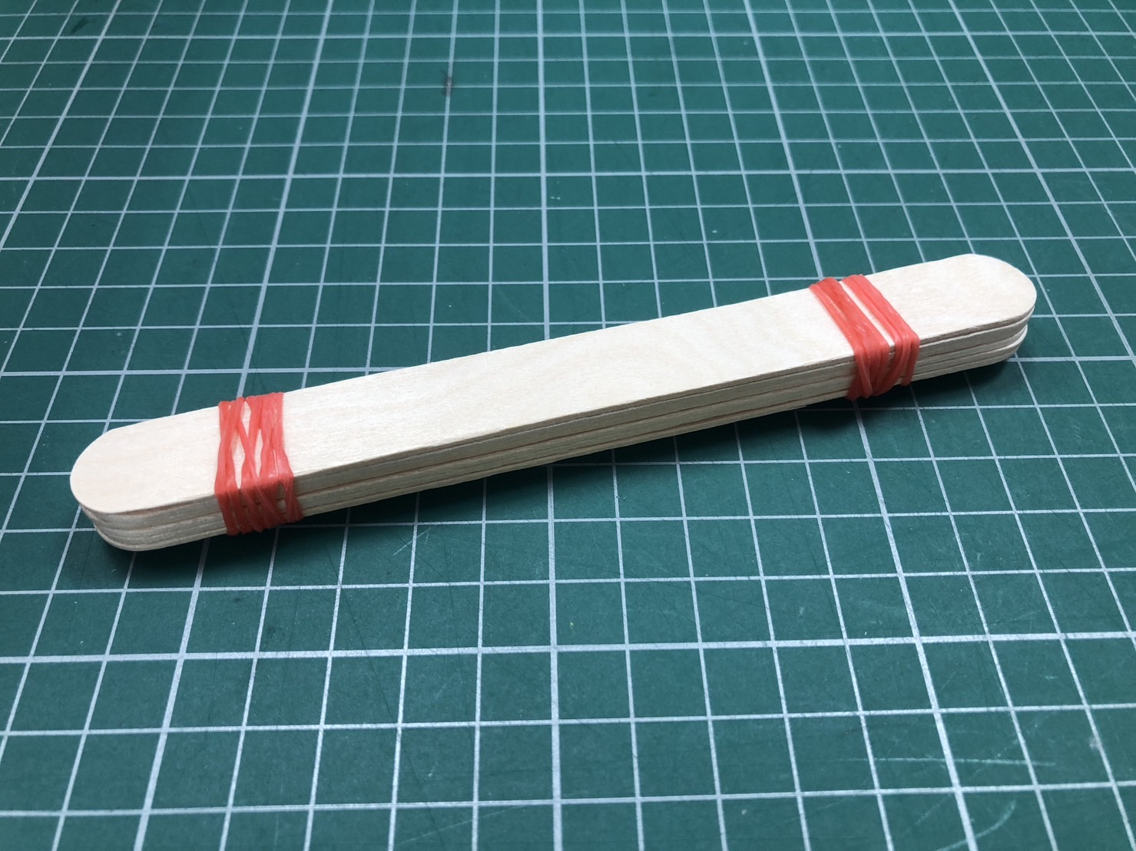 | 步驟四：取一張衛生紙揉成紙團。  Step 4: Take a piece of toilet paper and roll it into a ball. | 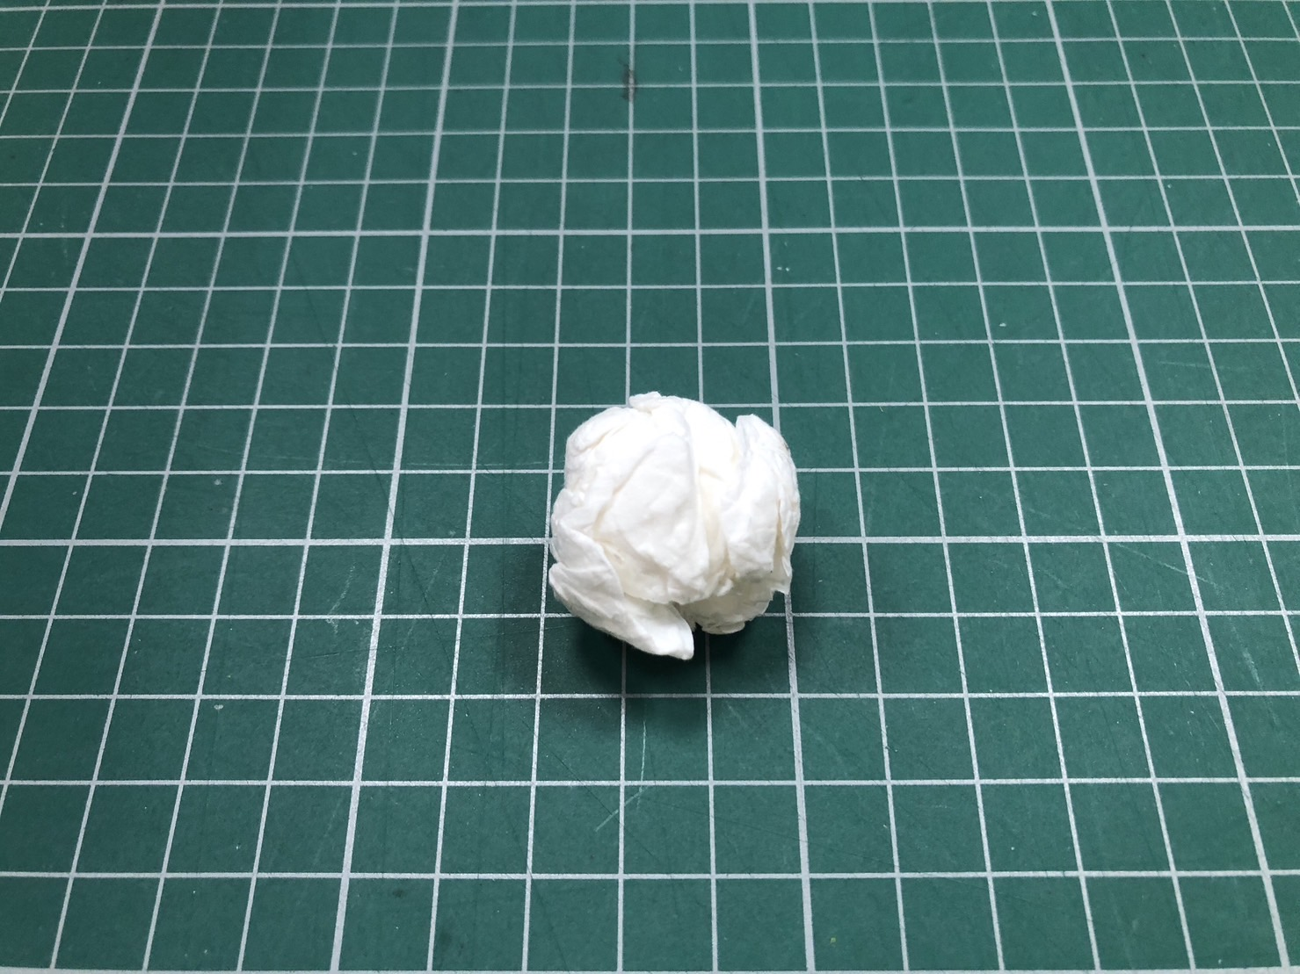
步驟五：將六枝冰棒棍橫放夾進兩根冰棒棍中間，可調整靠近瓶蓋或遠離瓶蓋。  Step 5: Place six popsicle sticks horizontally and sandwich them between two popsicle sticks. You can adjust them closer to the bottle cap or farther away from the bottle cap. | 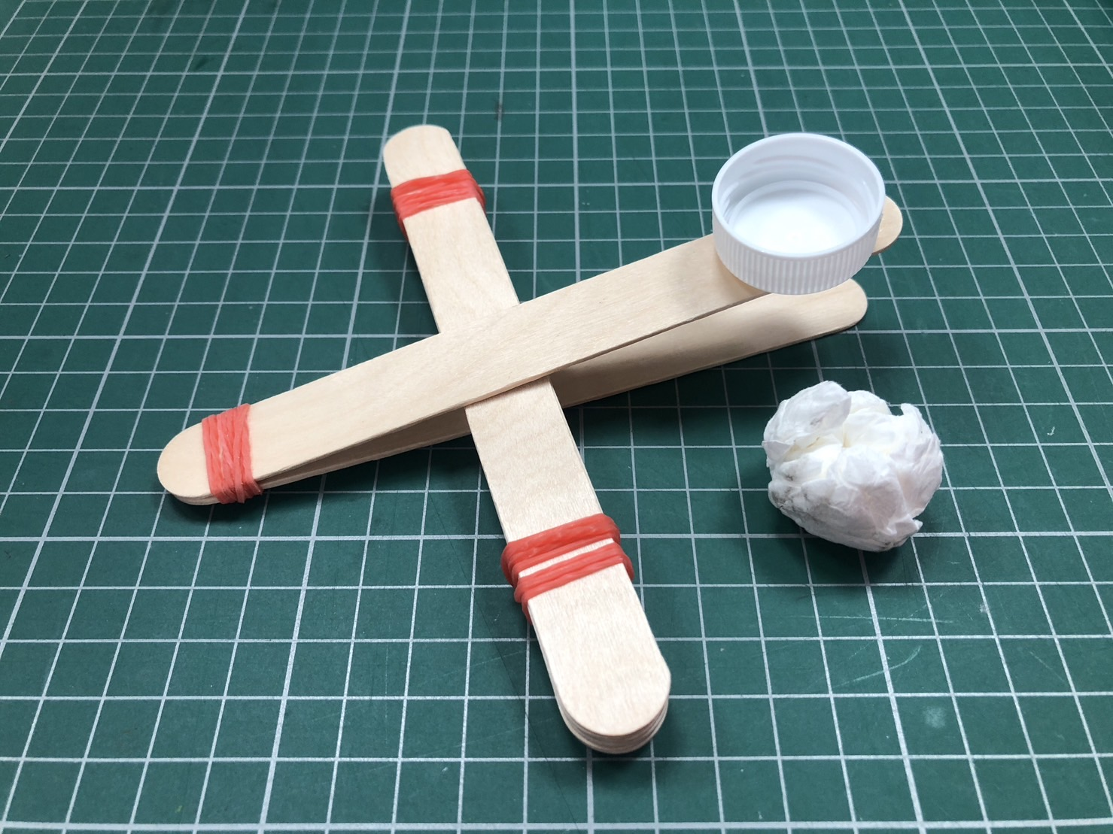 | 步驟六：將紙團放入瓶蓋中，壓下瓶蓋端的冰棒棍後放開，看看紙球能飛多高？多遠？  Step 6: Put the paper ball into the bottle cap, press down the popsicle stick at the end of the bottle cap and release it. See how high the paper ball can fly? How far? | 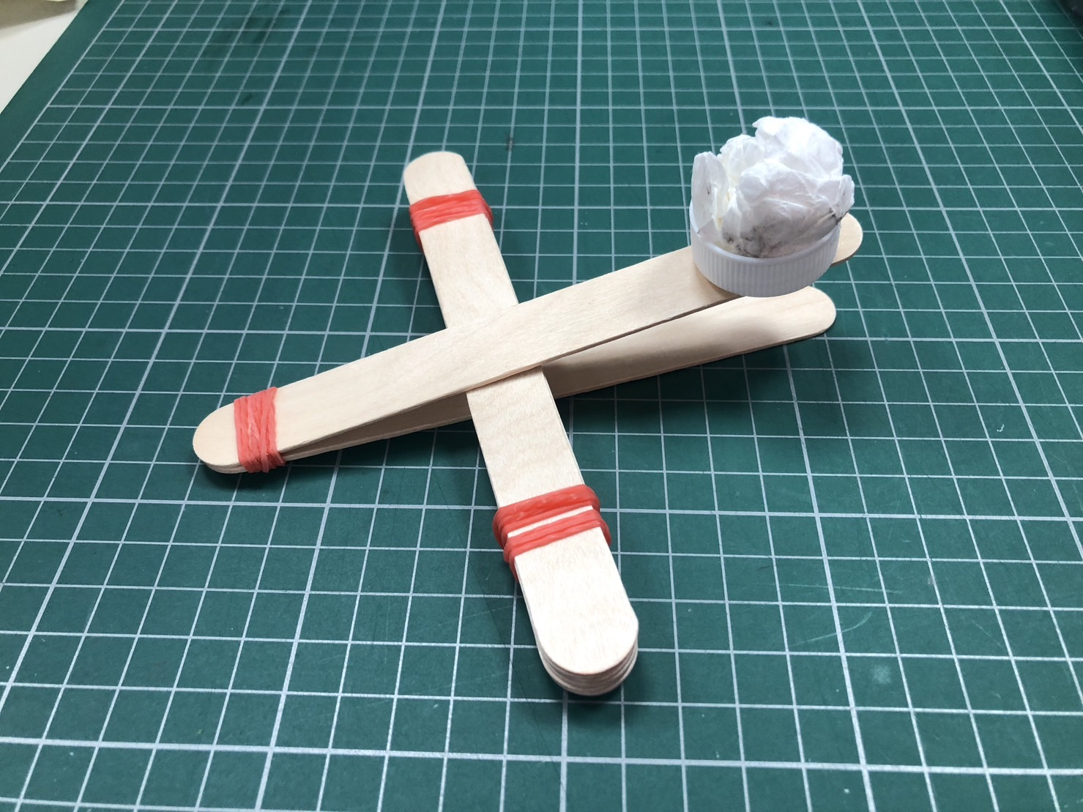

B.竹筷角錐版(Pyramid version)
步驟一：使用三枝竹筷綁出底座。 | 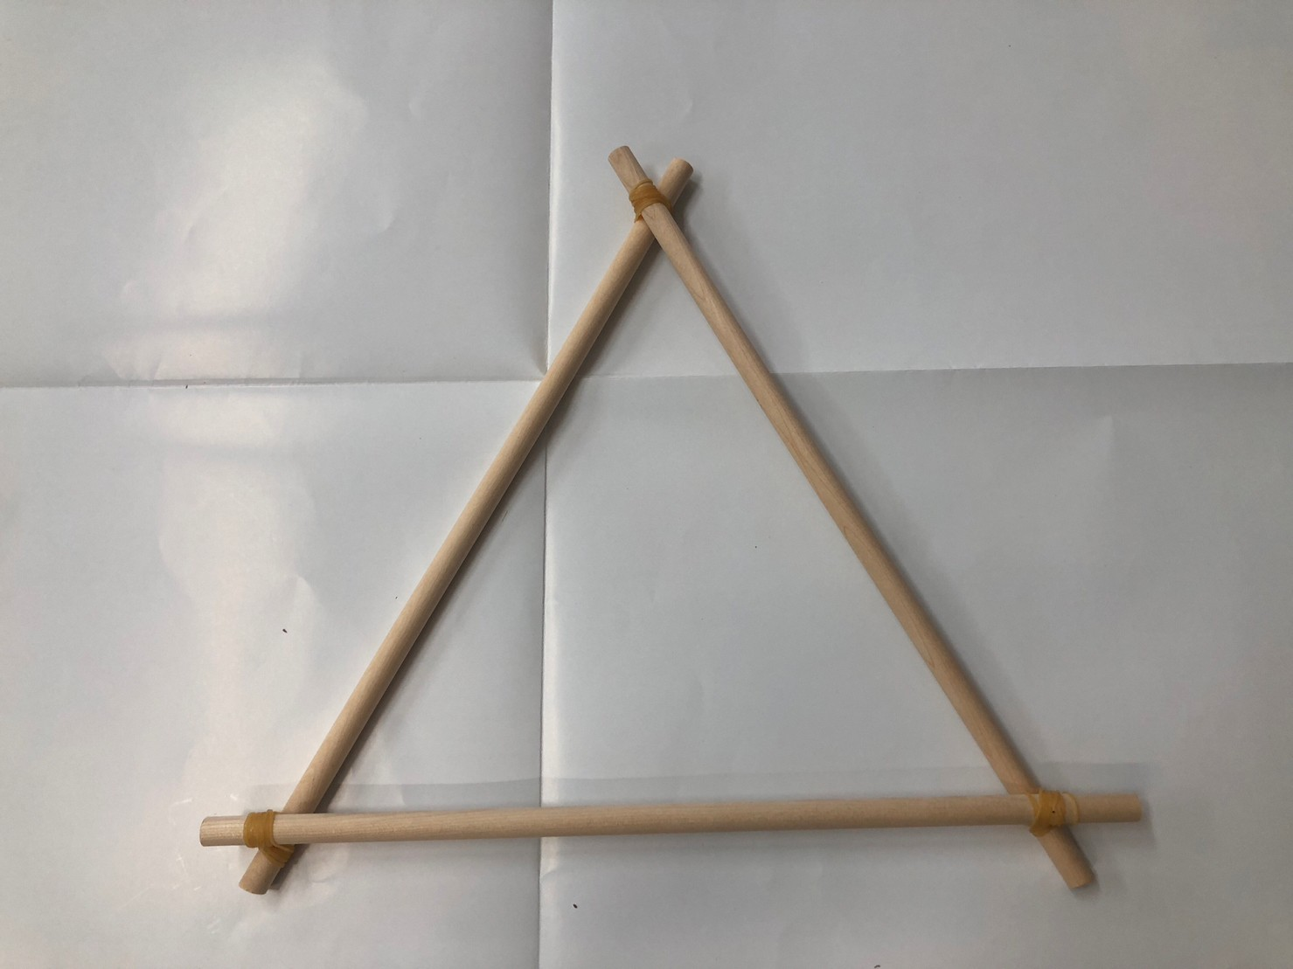 | 步驟二：在底座兩側再綁上兩根竹筷，頂端用橡皮筋固定。 | 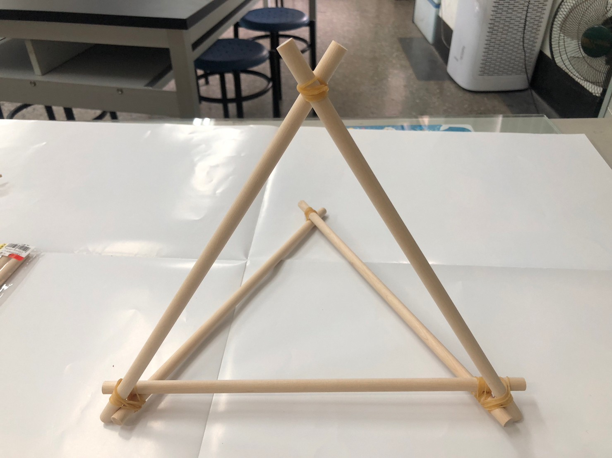
步驟三：使用兩根竹筷夾住上下兩個交叉處並綁緊。 | 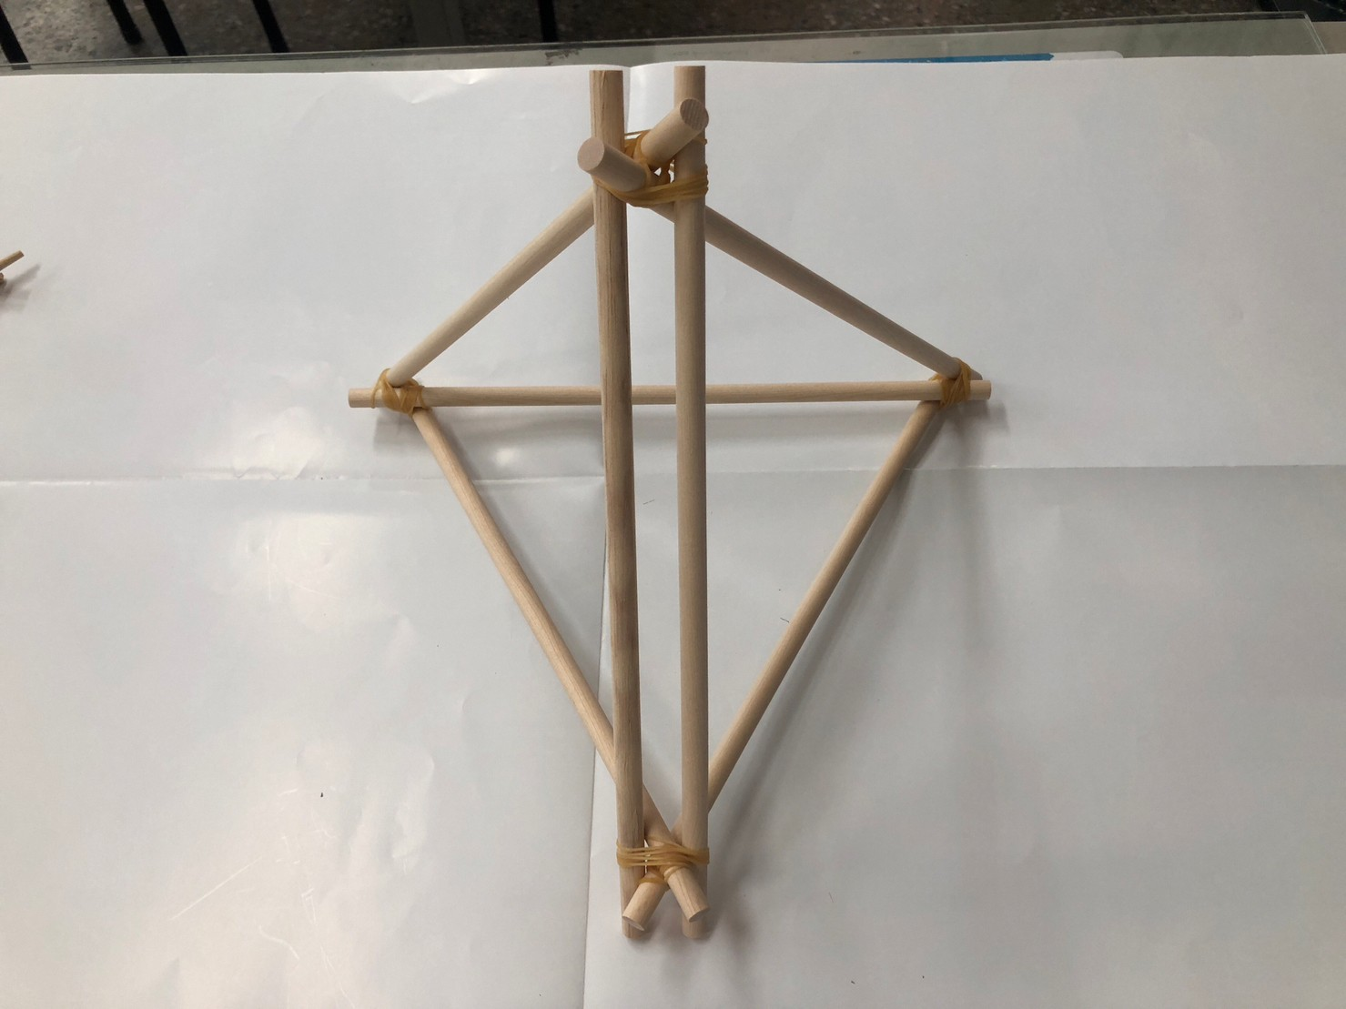 | 步驟四：另取兩根竹筷，大約在一半的位置綁上橡皮筋，然後在竹筷末端綁上一支湯匙。 | 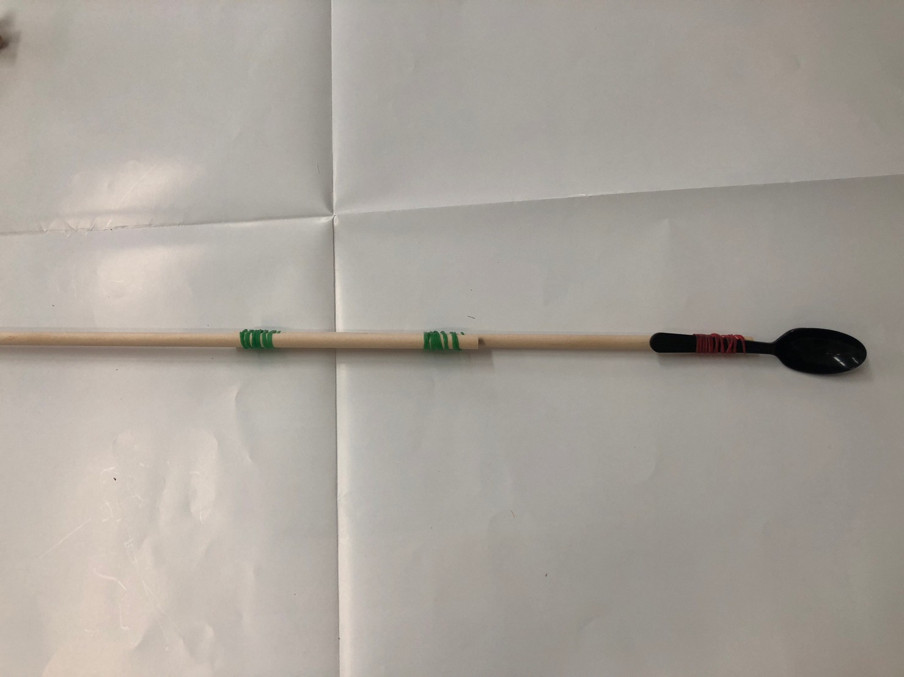
步驟五：將發射桿穿過兩根竹筷中間的縫隙，並在底座上用橡皮筋纏緊。 | 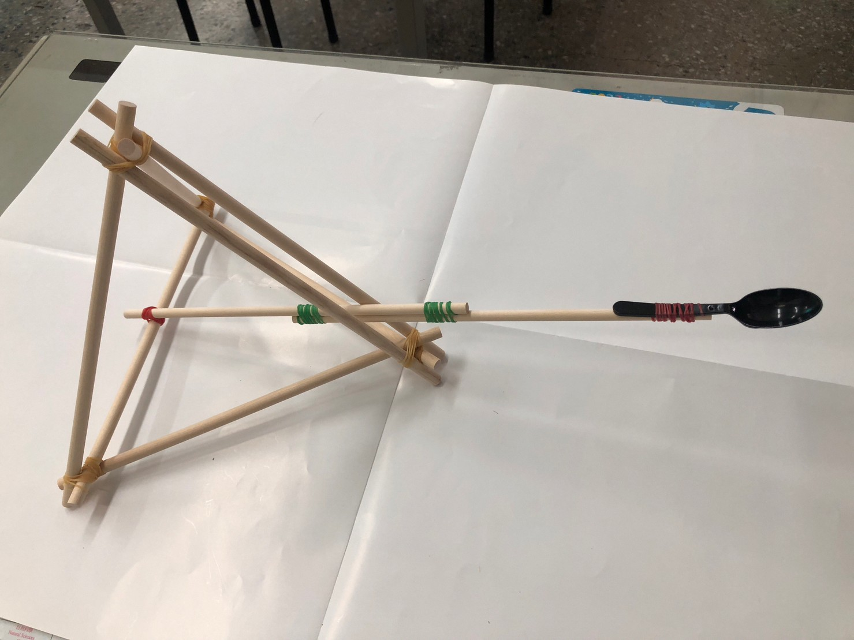 | 步驟六：套入三條橡皮筋後，再用一條固定，以免滑脫。 | 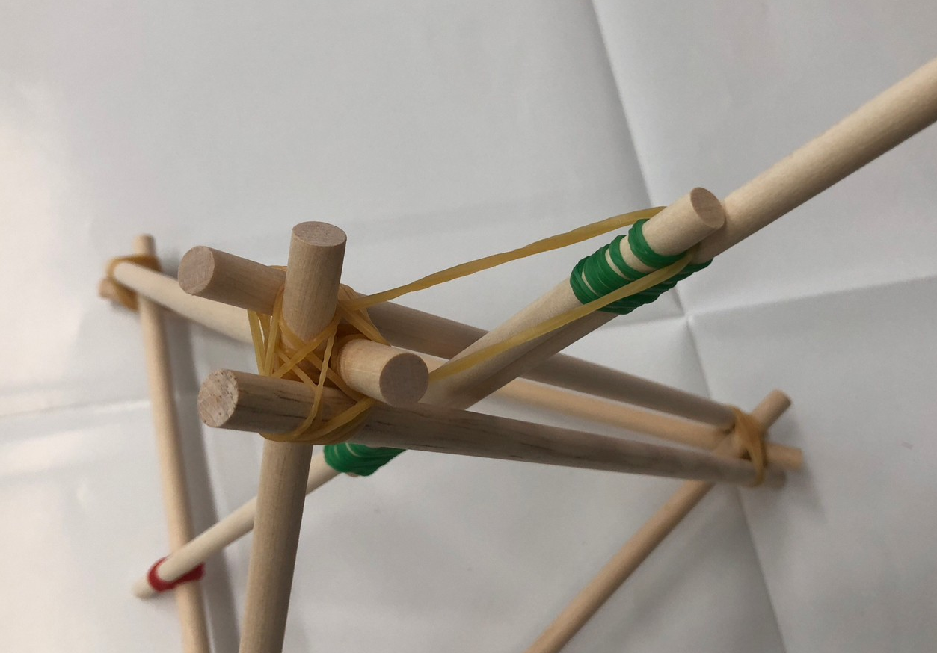
步驟七：用紙揉成紙球，並用膠帶綑綁緊實，每人做兩顆。 | 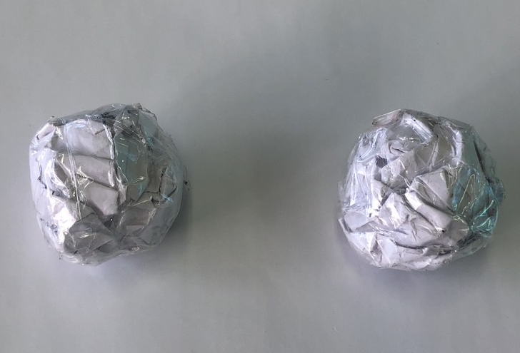 | 步驟八：將紙球放到湯匙上，並將湯匙向下壓後瞬間放掉，看紙球能飛多高？多遠？ | 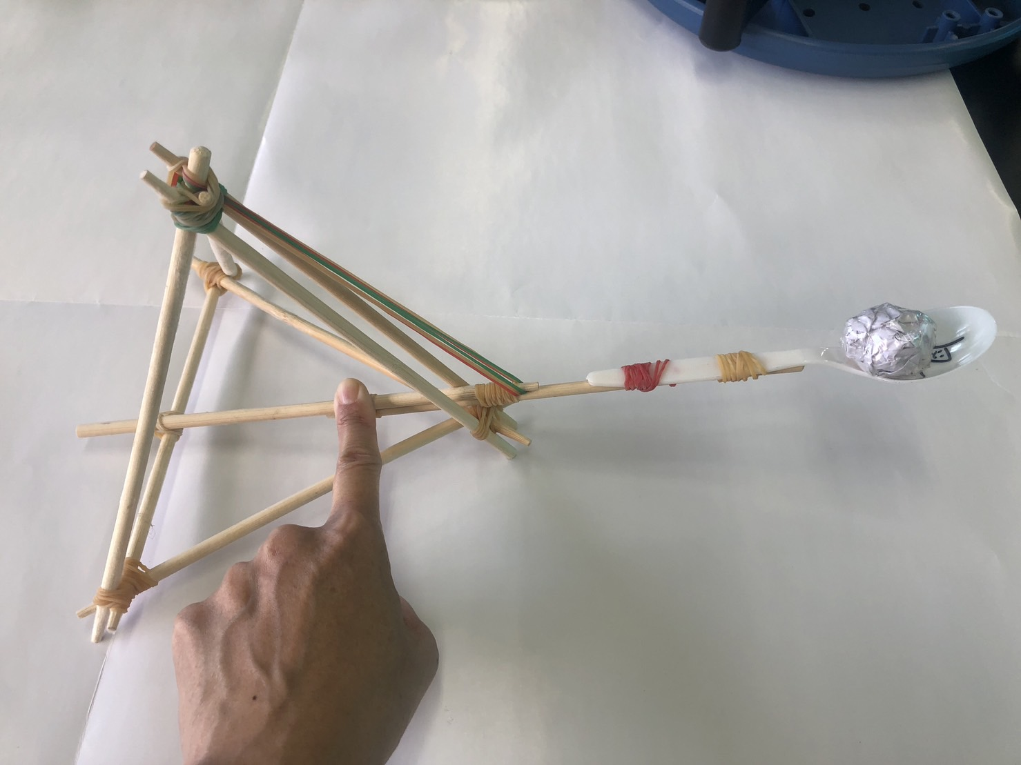

五、科學原理:
- 槓桿原理(lever principle)：在力學裡，典型的槓桿是置放連結在一個支撐點上的硬棒，這硬棒可以繞著支撐點旋轉，當槓桿靜力平衡時，其施力乘以施力臂等於抗力乘以抗力臂，作用在系統上的各力矩總和為零，這種現象稱為槓桿原理。
1. Lever principle: In mechanics, a typical lever is a hard rod connected to a support point. This hard rod can rotate around the support point. When the lever is statically balanced, its force multiplied by the force arm is equal to the resistance force multiplied by the resistance arm, the sum of the moments acting on the system is zero. This phenomenon is called the lever principle.
- 橡皮筋動力有兩種：一種是拉伸力，一種是扭轉力。拉伸力就是把橡皮筋拉長，它有彈力要把自己縮回來。另一種扭轉力就是把橡皮筋扭轉，它有彈力要把自己扭回來。這樣的位能與動能轉換，可以用來製作一些科學遊戲，或是手作玩具。
2. There are two types of rubber band power: one is stretching force and the other is twisting force. Stretch force stretches the rubber band, and it has the elasticity to retract itself. Another kind of twisting force is to twist the rubber band, which has elasticity to twist itself back. Such conversion of potential energy and kinetic energy can be used to make some scientific games or hand-made toys.
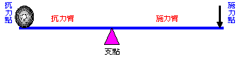
- 能量守恆：彈力位能轉化為動能，使紙球彈射出去，並分為垂直動能與水平動能。垂直動能使紙球彈到高位置，得到位能；水平動能使紙球獲得水平方向的初速度，決定彈射的距離。
3.Law of energy conservation: Elastic potential energy is converted into kinetic energy, causing the paper ball to eject, and is divided into vertical kinetic energy and horizontal kinetic energy. The vertical kinetic energy causes the paper ball to bounce to a high position and obtains potential energy; the horizontal kinetic energy causes the paper ball to obtain an initial velocity in the horizontal direction, which determines the distance of the ejection.

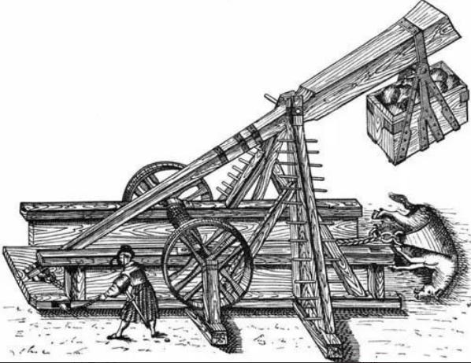
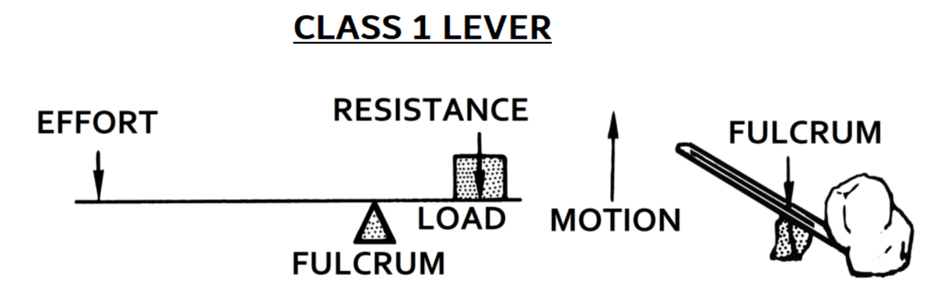
- 阿基米德當時的投石器到底長什麼樣子，已經沒有人知道，據科學家猜測，應是利用重力與槓桿原理的方式所製作。從圖中可以看見，右邊重物因地球引力而往下移動，隨之左邊桿子會被帶動往上擺盪，右邊重物桿子較短，轉動的距離短，也使得整體轉動速度加快，並連動讓左邊桿子擺盪速度也增加，最後當重物落地時，整個投石器瞬間停止運作，但杓子內的石頭因慣性的影響會繼續前進，而被投擲出去。

六、生活日常之運用：
1. 槓桿原理的應用分為三種，其中支點位於施力點與抗力點之間的器具，像剪刀、老虎鉗、翹翹板就是利用這種槓桿。如果施力臂(Force arm)長，抗力臂(Resisting arm)短，那就是省力工具。反之就是費力工具。如果施力臂等於抗力臂，那這工具不省力也不費力。
2. 橡皮筋被拉長，彈性位能（elastic potential energy）被儲存在橡皮筋裡。一旦鬆開手，橡皮筋就會恢復原狀，同時將能量釋放出來，轉換為物品所需的動能，例如：彈跳玩具、竹筷槍。

七、參考資料：
1. 國立台中教育大學科學教育與應用學系-科學遊戲實驗室 http://scigame.ntcu.edu.tw/engine/engine-005.html
2. 橡皮筋也能玩科學？5種超簡單橡皮筋玩法、STEAM手作玩具教學【2023年版】https://tw.toybrains.com/blog/5-rubber-band-diy-activities
3. 康軒學習雜誌https://www.top945.com.tw/celebrity_Data.asp?ID=176
4. 槓桿原理https://www.njes.chc.edu.tw/w2/magicscience12/back/010.htm

