搭橋總動員
Let’s Build an Arch bridge!
校名：高雄市苓雅區福康國小
Kaohsiung Fukang Elementary School

指導老師：馬健傑、謝鐵惠、謝宗翰
Instructor: Frank Ma, Rita Hsieh, Han Hsieh

- 旨趣(或目的)Learning Objectives
透過實際操作以木條模擬，搭建出最長跨距的拱型橋梁架構，藉此了解中國古代搭建橋樑時所運用的其中一種方式。
During hands-on activities, participants learn to build small-scale arch bridges using wooden sticks to form a girder-and-dowel structure, thus spanning longer distance than the length of the individual stick. Participants are also introduced to ancient Chinese methods of bridge building.
- 實驗器材Materials: 長形木條。long wooden sticks
- 活動過程Activity Procedure：完成二關的考驗，即可蓋章。
Students work in pairs or groups to experiment with building a bridge. A stamp will be given to participants after finishing two missions.
- 第一關：利用9根木條完成基本拱橋。
Mission 1: Build a basic arch bridge with nine sticks.
第二關：利用15根木條完成拱橋。
Mission 2: Build a longer arch bridge with fifteen sticks.

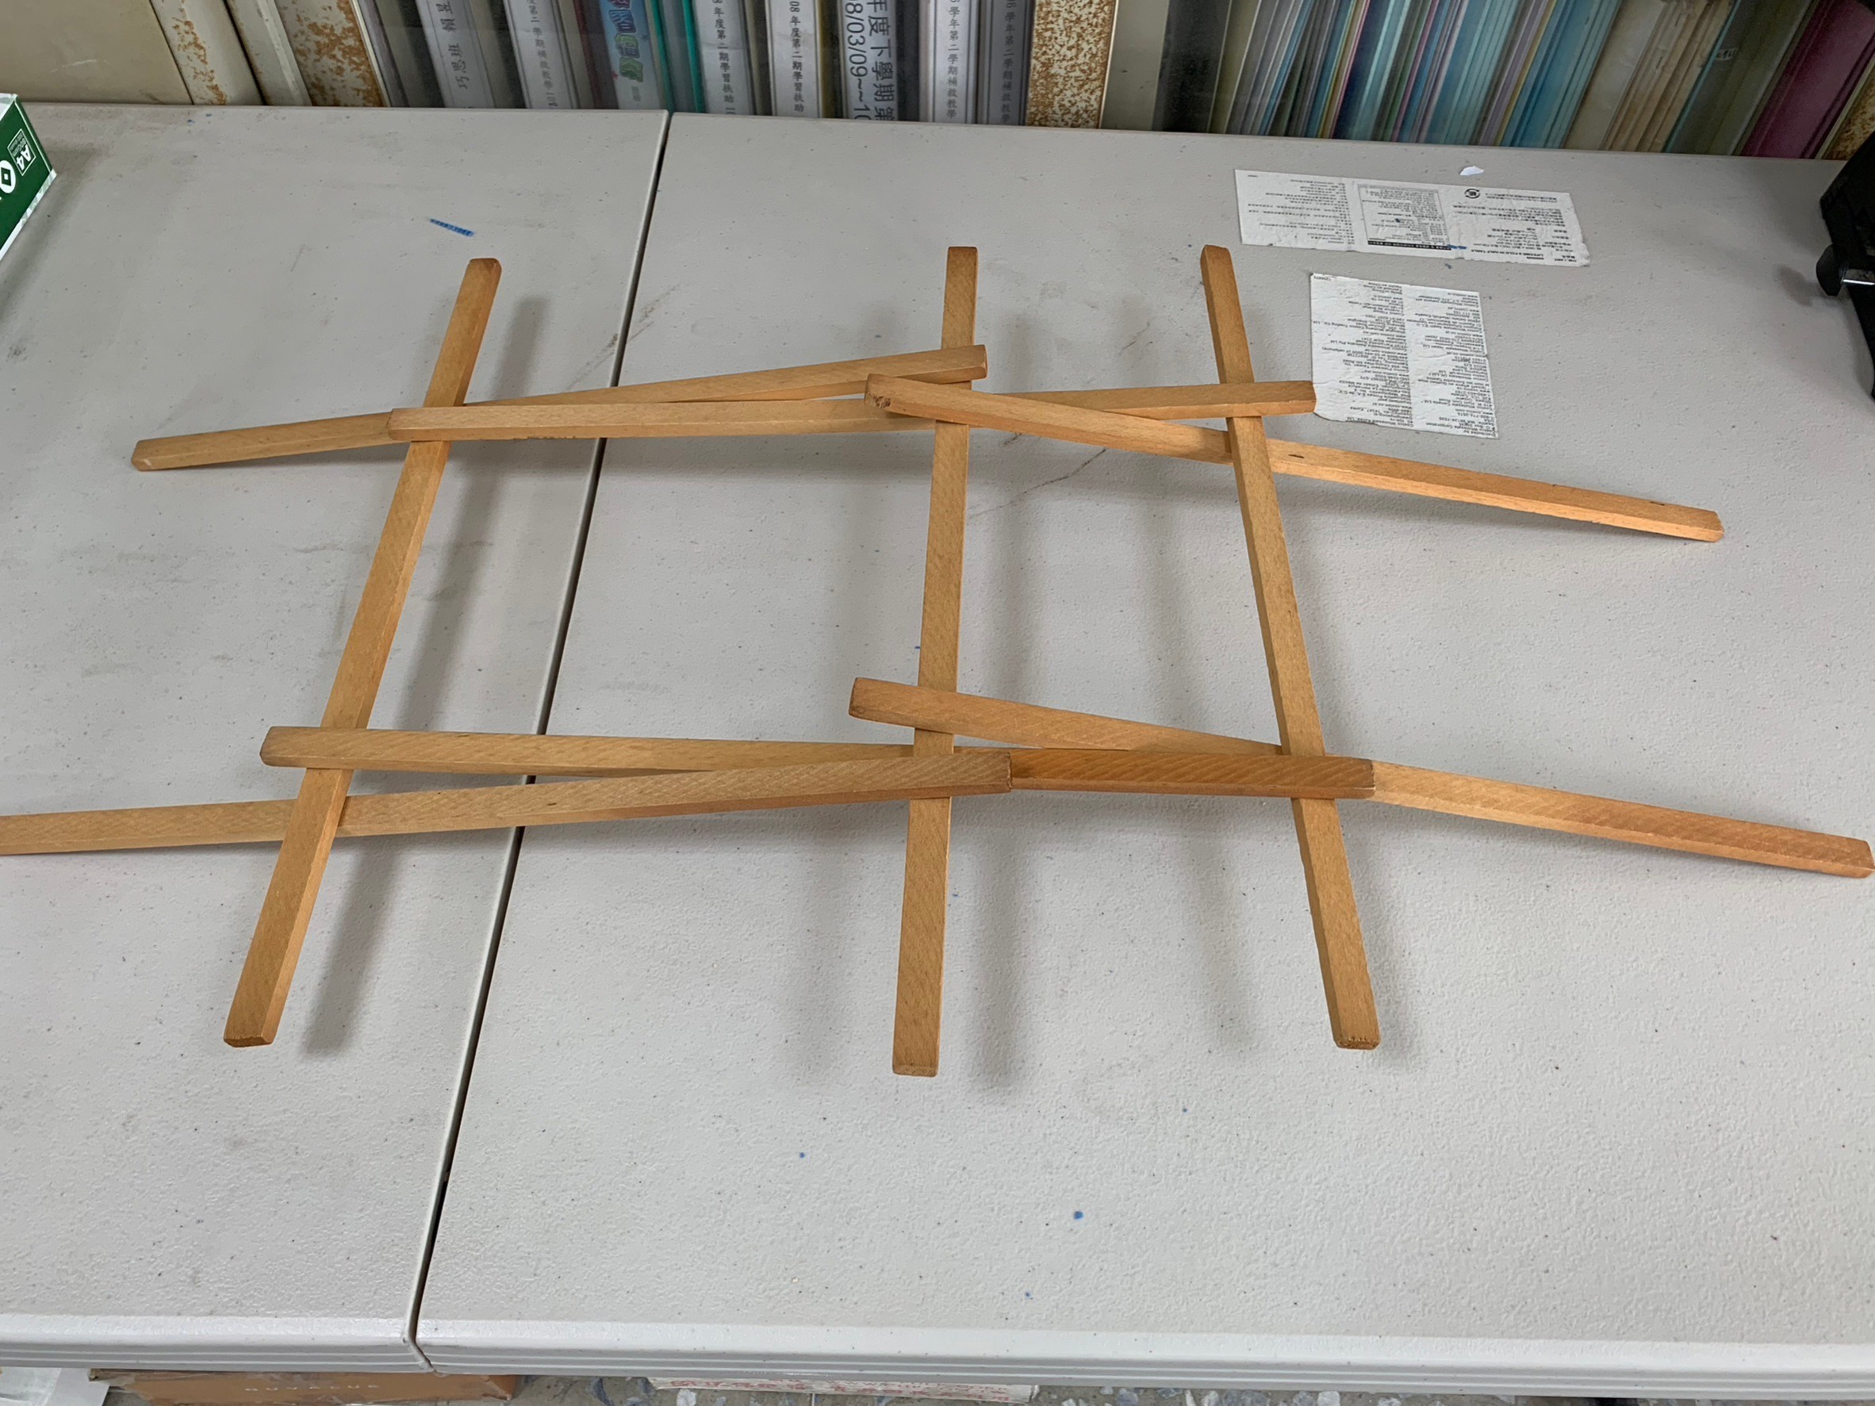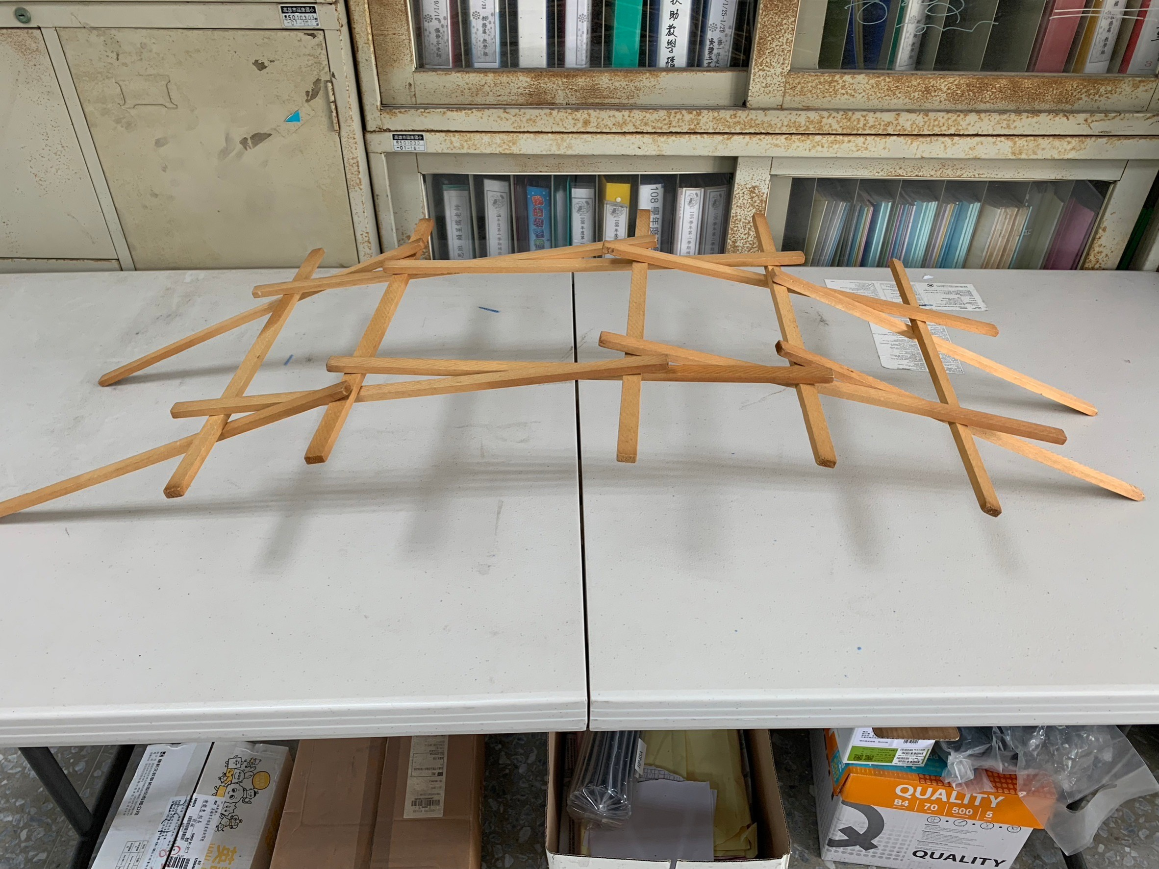
（圖一）Picture 1 （圖二）Picture 2

- 活動啟示(或原理探討)Bridge Support Structure Concepts
這是運用支點支撐的結構力學實驗，這個實驗只是初步讓國小學生了解以下三點：（一）中國古代簡易搭橋力學概念。（二）透過正確支點的建立取得力學平衡。（三）特性為不用釘鉚，僅靠木材本身的強度、摩擦力及重力形成拱橋。
This hands-on activity offers a simple experimental approach to understanding the principles of structural mechanics by loading the pivots with a force. This experiment provides primary school students with an initial understanding of the following three points:
- Simple bridge building mechanics in ancient China.
- How mechanical balance is achieved through the establishment of correct pivots.
- Without niches for the dowels, friction holds the structure together. When the self-weight and other loads are applied, the strength of the wood determines the load-bearing capacity.

