高雄市113年度第43屆國民中小學科學園遊會 高雄市鳳山區中正國小

Kaohsiung Primary and Junior High Schools Science Lawn Party

Kaohsiung Fengshan District Zhongzheng Elementary School

**「牛」言「非」語**

Exploring the Magic of Non-Newtonian Fluids

學生：蔡璨陽、莊恩齊、張允嘉、莊子杰、張育緁、彭得堉

高瑋辰、洪唯誠、顏呈恩、侯昀儒、林睿穎、莊喬羽

王愉茜、王愉閑、魯哲維、張祐溥、洪唯碩、陳子庭

陳昱睿、施竣凱、邱莘嵐、林妤庭、魏妍容、張聿緹

1. 活動主旨Activity Objectives  
   　　透過實際操作非牛頓流體裝置的體驗，讓小朋友親身感受玉米澱粉的非牛頓流體特性，激發他們對科學的興趣與好奇心。  
   　　闖關過程中，將透過觀察與互動，讓小朋友了解：當施加壓力時，玉米澱粉會變得像固體一樣堅硬；然而在放鬆壓力時，則又恢復為流體狀態的奇妙現象。  
   　　並結合藝術與AI資訊科技，融入美感教育，啟發小朋友美感素養，且可流暢運用AI科技，將原有作品利用AI獲得新生。  
   　　這項活動不僅能讓孩子們動手操作，培養他們的創意思維與問題解決能力，還能輕鬆學習到日常生活中的科學原理，在遊戲中探索物理的奧妙，甚至能啟迪對於美學的素養，並學習操作逐漸深入我們日常生活中的AI智慧。  
    By engaging in hands-on experience with non-Newtonian fluid devices, children can directly observe the unique properties of cornstarch as a non-Newtonian fluid, sparking their curiosity and interest in science.

During the challenge, through observation and interaction, children will understand that when pressure is applied, the cornstarch becomes solid and hard, but when the pressure is released, it returns to its fluid state.

The activity also integrates art and AI technology, incorporating aesthetic education to inspire children’s sense of beauty and enabling them to use AI technology seamlessly, breathing new life into their original creations through AI.

This activity not only allows children to engage in hands-on learning, fostering their creative thinking and problem-solving skills, but also helps them easily grasp scientific principles from daily life, exploring the wonders of physics through play. Additionally, it enhances their appreciation for aesthetics and teaches them to navigate the AI technologies increasingly embedded in our everyday lives.

1. 名詞解釋Definition of terms
   1. 非牛頓流體Non-Newtonian fluids  
       非牛頓流體是一種流體力學的概念，與牛頓流體相對。其主要特徵在於剪應力與剪切速率之間的關係不遵循牛頓黏性定律，這意味著它的黏度會隨著施加的外力或剪切速率的變化而改變。  
       非牛頓流體可以根據其行為分為幾種類型：

剪切稀化：這類流體的黏度隨著施加的剪切力增加而減少，如油漆和某些清潔劑。當這些流體受到攪拌或擠壓時，它們變得更容易流動。

剪切增稠：相反，這類流體的黏度會隨著剪切力的增加而增大，導致流動性減弱。常見例子包括玉米澱粉和水的混合物，當快速施加力量時，它會變得堅硬，能承受重物。  
 一些常見的非牛頓流體包括：牙膏、強力膠、水泥漿、玉米澱粉和水的混合物，這些流體在日常生活中廣泛存在，並且因其獨特的物理性質而被廣泛應用於各種工業和科學領域

A non-Newtonian fluid is a concept in fluid mechanics, in contrast to a Newtonian fluid. Its primary characteristic is that the relationship between shear stress and shear rate does not follow Newton's law of viscosity. This means its viscosity changes depending on the applied force or shear rate.  
  
 Non-Newtonian fluids can be classified into several types based on their behavior:

Shear thinning: The viscosity of this type of fluid decreases as the applied shear force increases, such as in paints and some cleaning agents. When these fluids are stirred or squeezed, they become easier to flow.  
  
 **Shear thickening**: In contrast, the viscosity of these fluids increases as the shear force increases, leading to reduced fluidity. A common example is a mixture of cornstarch and water, which becomes firm when force is applied quickly, allowing it to support weight.  
  
 Some common non-Newtonian fluids include toothpaste, super glue, cement slurry, and mixtures of cornstarch and water. These fluids are widely present in daily life and are extensively used in various industrial and scientific fields due to their unique physical properties.

* 1. 非牛頓流體中的非線性擴散nonlinear diffusion in non-Newtonian fluids  
     　　非線性擴散在非牛頓流體中的解釋涉及流體的運動行為和應力反應的複雜性。在非牛頓流體中，非線性擴散描述了物質或能量在流體中傳播的過程，這一過程受到流體內部結構和外部條件的影響。  
     　　由於非牛頓流體具有記憶效應，其過去的運動狀態會影響當前的擴散行為，這使得擴散過程變得更加複雜。  
     　　但同時，非線性擴散在工程和科學研究中也有重要應用，例如在材料科學中，設計新型非牛頓流體以改善其性能；在生物醫學中，研究血液等生物液體的流動特性。這些應用需要考慮到非線性擴散對於流動和傳輸過程的影響，以達到更好的控制和預測效果。  
     　　總結來說，非線性擴散在非牛頓流體中的解釋涉及其獨特的物理特性及其對於流動行為的影響。  
     　　Nonlinear diffusion in non-Newtonian fluids involves the complexity of fluid motion and stress responses. In non-Newtonian fluids, nonlinear diffusion describes the process of substance or energy propagation within the fluid, which is influenced by both the internal structure of the fluid and external conditions.

　　Due to the memory effect inherent in non-Newtonian fluids, their past motion states affect current diffusion behavior, making the diffusion process more complex.

　　At the same time, nonlinear diffusion has significant applications in engineering and scientific research. For instance, in materials science, it is used to design new non-Newtonian fluids to improve performance, and in biomedical studies, it helps analyze the flow characteristics of biological fluids like blood. These applications require consideration of the impact of nonlinear diffusion on flow and transport processes to achieve better control and predictive outcomes.

　　In summary, the explanation of nonlinear diffusion in non-Newtonian fluids involves their unique physical properties and how these properties influence flow behavior.

* 1. AI生成式圖片AI-Generated Artwork  
     　　AI 生成式圖片是指利用人工智慧技術自動生成的圖片。這種技術通常基於深度學習模型，如生成對抗網絡（GAN）或擴散模型，能夠根據文字描述、草圖或其他輸入來創建圖像。用戶可以輸入文字提示，AI 會根據提示自動生成符合要求的圖片，這種方式在藝術創作、設計、自動化插畫等領域應用廣泛。

　　例如，使用Copilot模型，輸入「日落時的海灘，天空中有粉紅色和橙色的雲」，AI 會自動生成這樣場景的圖片。

AI 生圖技術可以大幅減少創作時間，也為那些沒有繪畫技能的人提供了創造視覺作品的可能性。  
　　透過上述技術，AI生成式圖片技術被廣泛應用於各種領域，例如藝術創作、商業設計、遊戲動畫等。AI生成式圖片技術不僅提升了創作效率，也為藝術與設計領域帶來了新的可能性。隨著技術的不斷進步，未來將會有更多創新應用出現。  
　　AI-generated artwork refer to pictures automatically created using artificial intelligence technology. This technique typically relies on deep learning models, such as Generative Adversarial Networks (GANs) or diffusion models, which can create images based on textual descriptions, sketches, or other inputs. Users can input text prompts, and the AI will automatically generate images that meet the requirements. This approach is widely applied in fields such as artistic creation, design, and automated illustration.

　　For example, using a model like Copilot, if you input “a beach at sunset with pink and orange clouds in the sky,” the AI will automatically generate an image of that scene. AI image generation technology can significantly reduce creation time and offers the possibility for those without drawing skills to create visual works.

　　Using these technologies, AI-generated artwork techniques have been widely applied in various fields, such as artistic creation, commercial design, and game animation. Not only has this technology increased creative efficiency, but it has also introduced new possibilities in the fields of art and design. With continuous advancements in AI, even more innovative applications are expected to emerge in the future.

1. 材料準備

|  |  |
| --- | --- |
|  |  |
| 玉米澱粉、小盆子 | 杯子、竹筷 |
|  |  |
| 彈珠 | 白紙 |
|  |  |
| 水性食用色素 | 湯匙 |

1. 關卡活動Challenge activity
   1. 此牛非彼牛The basic properties of non-Newtonian fluids  
       首先，請闖關者將插在杯中液體的竹筷用力拔起。(如圖一)會發現，插在溶液裡的竹筷難以快速拔起。請小朋友思考竹筷難以快速拔起的原因。  
       接著，講解實驗原理：因插在杯中的液體是玉米澱粉溶液，而玉米澱粉溶液屬於非牛頓流體，非牛頓流體的黏度會隨著外力變化而改變，它們的流動性受外力影響。例如，番茄醬、泥漿都是非牛頓流體。  
       小朋友可透過此次實驗了解非牛頓流體與一般流體不同的特性。  
       First, participants are asked to forcefully pull a bamboo chopstick out of the liquid in the cup. They will notice that it is difficult to pull the chopstick out quickly. Children are then encouraged to think about the reason why the chopstick is hard to pull out rapidly.  
        
       Next, explain the principle behind the experiment: The liquid in the cup is a cornstarch solution, which is a non-Newtonian fluid. The viscosity of non-Newtonian fluids changes with the application of external forces, meaning their flow behavior is affected by external pressure. For example, ketchup and mud are both non-Newtonian fluids.  
        
       Through this experiment, children can understand the unique properties of non-Newtonian fluids compared to ordinary fluids.

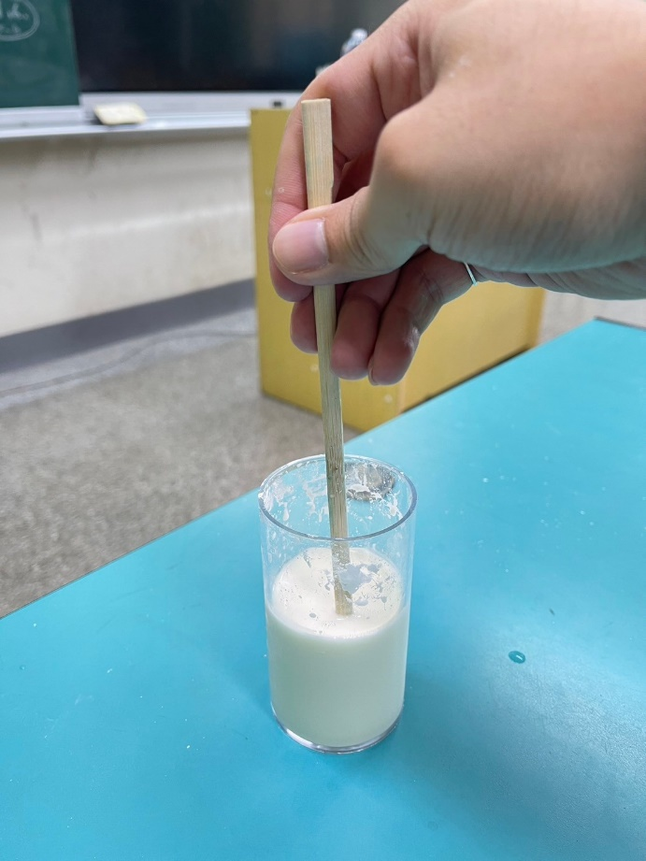

圖一

* 1. 「牛」刀小試─「硬」拉~  
     The phenomenon of dilatancy in non-Newtonian fluids  
      請小朋友在限定時間內，用湯匙將一顆寶貝球從『非牛頓魔法沼澤』中成功救援出(如圖二)，即可過關。  
      接著說明原理，非牛頓流體的黏度會因為受到的壓力或速度不同而發生變化。當流體受到的壓力越大時，溶液裡的分子會被擠壓呈現排列整齊，導致液面瞬間黏度增加，因而形成一個暫時性堅硬的固體表面。相反的，若是緩慢的施加外力，則分子會呈現較鬆散的狀態，就呈現類似液體的情況。  
      Children must scoop a marble out of the cornstarch solution using a spoon within a limited time to complete the challenge.  
       
      Explanation of the principle: The viscosity of non-Newtonian fluids changes depending on the pressure or speed applied. When greater pressure is applied to the fluid, the molecules in the solution are compressed and become more orderly, causing a sudden increase in viscosity, which creates a temporary solid surface. On the other hand, if force is applied slowly, the molecules remain more loosely arranged, resulting in a liquid-like behavior.

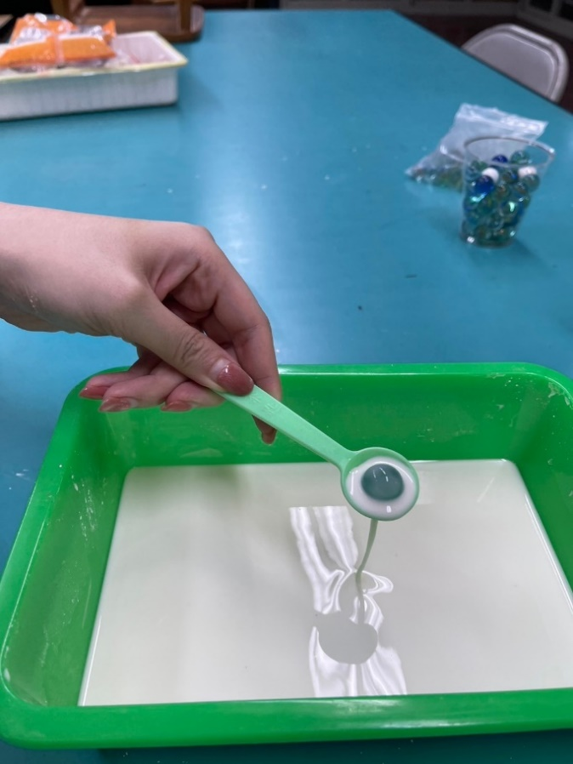

圖二

* 1. 牛「P」Picture of Non-Newtonian fluid  
      首先，將水性顏料到在玉米澱粉溶液上(如圖三、圖四)，並請小朋友觀察顏料在玉米澱粉溶液中擴散的情況。  
      接著，將紙輕輕覆蓋在倒了顏料的玉米澱粉上(如圖五)，將顏料拓印到紙上。  
      原理說明，顏料遇到玉米澱粉時，由於玉米澱粉的表面黏稠，顏料就沒辦法順利滲入或擴散，只能停留在表面。因此，便可以利用這項特性，將顏料拓印到紙上，得到一張玉米澱粉的顏料拓印畫(如圖六)。  
      First, pour watercolor paint onto the cornstarch solution and ask the children to observe how the paint diffuses in the cornstarch solution.  
       
      Next, gently place a piece of paper over the cornstarch solution with the paint and press down lightly to transfer the paint onto the paper.  
       
      Explanation of the principle: When the paint comes into contact with the cornstarch, the thick surface of the cornstarch prevents the paint from penetrating or diffusing effectively, causing it to remain on the surface. Therefore, this characteristic can be utilized to transfer the paint onto the paper, resulting in a cornstarch paint print.

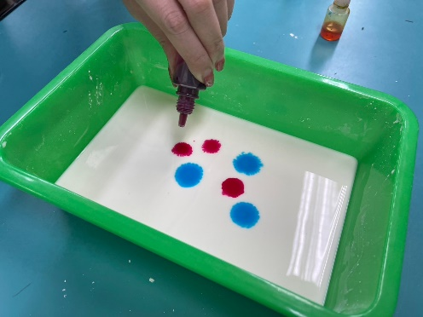 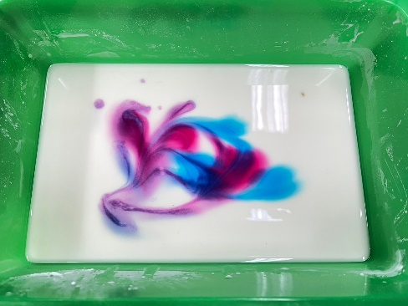

圖三 圖四

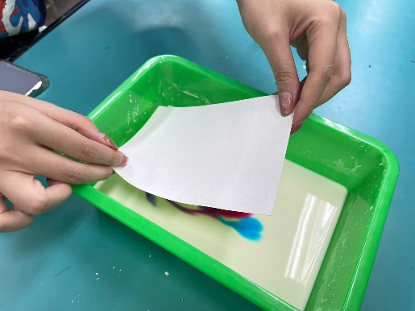 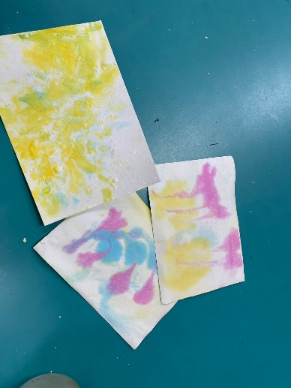

圖五 圖六

* 1. 「A」牛Using AI to generate artwork  
      小朋友將拓印完的渲染畫，使用IPad拍起來，並運用Copilot AI軟體生成只屬於他們自己的寶可夢作品(如圖七)。  
      小朋友可以在此活動中學習如何有效地對AI下正確的指令。  
      Children can take pictures of their printed artwork using an iPad and then use Copilot AI software to generate their own unique Pokémon creations.  
       
      Children can learn how to effectively give correct instructions to AI during this activity.

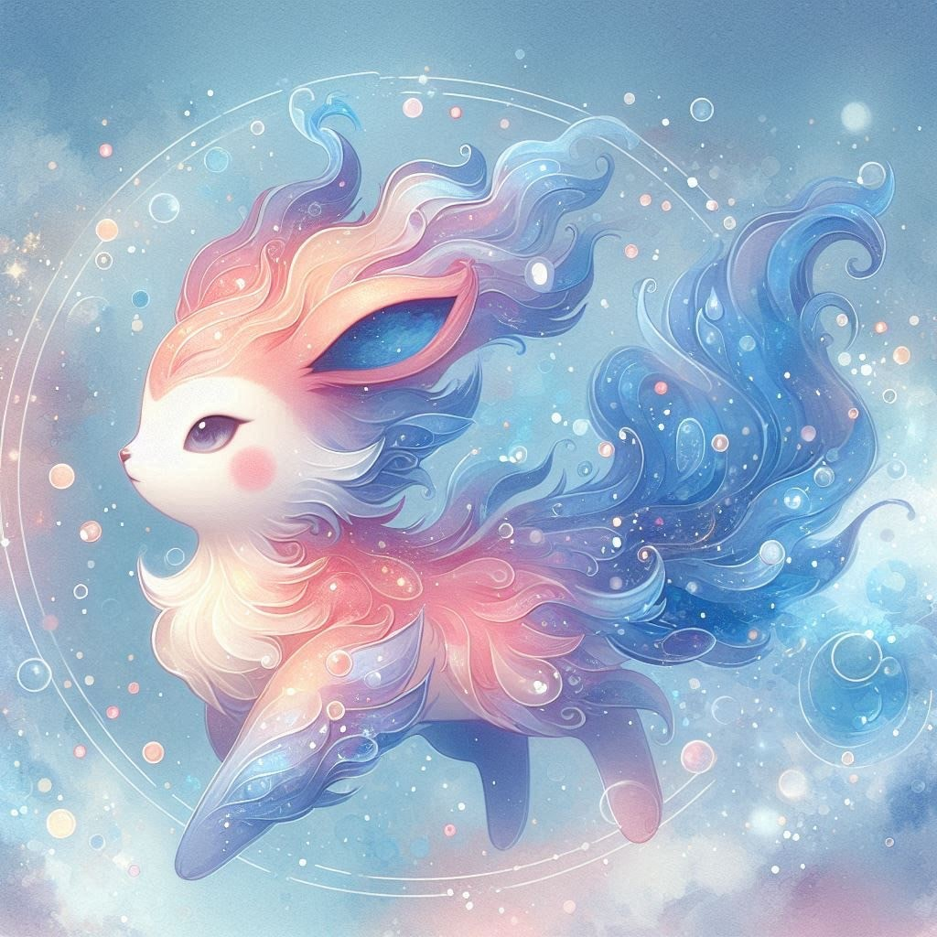

圖七

1. 結果與討論Discussion and Conclusion  
   小朋友將可在此活動中，發現：
   1. **非牛頓流體的力學特性**：  
      　　在活動1中，學生嘗試將插在玉米澱粉溶液中的竹筷快速拔出時，會發現它難以被迅速移動。這是因為非牛頓流體在受到突然的力時，其內部阻力增強，呈現固體特性。這讓學生直觀地感受到，非牛頓流體的流動性取決於外力的大小和施力的速度。

　　學習成果：學生能夠體會到非牛頓流體的力學特性——當受到壓力或外力時，液體會呈現固體特性，沒有壓力時則像液體一樣流動。

* 1. **非牛頓流體的擴散特性**：  
     　　在活動2中，學生使用湯匙嘗試撈出玉米澱粉溶液中的彈珠，並發現隨著湯匙的施力不同，溶液的粘稠度和流動性改變，這讓他們了解到非牛頓流體的擴散特性。當力增加時，溶液的擴散受到限制，粘稠度變高。

　　在活動3中，將水性顏料倒在玉米澱粉溶液上，小朋友會觀察到水性顏料在非牛頓流體中的擴散速度變慢，這是因為非牛頓流體內部的粘稠性限制了顏料的擴散。

　　學習成果：學生能理解非牛頓流體的擴散特性與一般流體不同，流體中顆粒的流動速度取決於外力和粘度的變化。

* 1. **對ＡＩ下達有效的指令**：  
     　　在活動4中，學生將使用IPad拍攝渲染畫，並運用Copilot AI生成他們的專屬作品。他們將學習如何準確地描述想要生成的作品，從而對AI下達明確的指令。

　　學習成果：學生會理解到，對AI的輸入越精確，輸出的結果越接近預期。這將幫助他們學會如何用清晰、具體的語言與AI互動，並提升數位時代下的問題解決能力。

期許這些學習成果不僅能增強他們的科學素養，還能激發對學習的興趣與熱情。

Students will discover in this activity:

* 1. Mechanical Properties of Non-Newtonian Fluids:

In Activity 1, when students attempt to quickly pull a chopstick out of a cornstarch solution, they will notice that it is difficult to move swiftly. This is because, when a sudden force is applied, the internal resistance of the non-Newtonian fluid increases, causing it to behave like a solid. This gives students a hands-on understanding that the flow properties of non-Newtonian fluids depend on the magnitude and speed of the applied force.

Learning Outcome:

Students will grasp the mechanical properties of non-Newtonian fluids—when subjected to pressure or external force, the fluid behaves like a solid, while in the absence of pressure, it flows like a liquid.

* 1. Diffusion Properties of Non-Newtonian Fluids:

In Activity 2, students use a spoon to try and retrieve a marble from the cornstarch solution. They will notice that as the force applied with the spoon varies, the viscosity and fluidity of the solution change. This helps them understand the diffusion properties of non-Newtonian fluids. When more force is applied, the diffusion is restricted, and the viscosity increases.

In Activity 3, when water-based paint is poured onto the cornstarch solution, students will observe that the paint diffuses more slowly in the non-Newtonian fluid. This is because the internal viscosity of the fluid limits the diffusion of the paint.

Learning Outcome:

Students will understand that the diffusion properties of non-Newtonian fluids differ from those of regular fluids. The movement of particles within the fluid depends on changes in external force and viscosity.

* 1. Giving Effective Commands to AI:

In Activity 4, students will use an iPad to take photos of their rendered artwork and then use Copilot AI to generate their own unique creations. They will learn how to accurately describe the artwork they want to generate, thereby giving clear and precise instructions to the AI.

Learning Outcome:

Students will understand that the more precise their input is, the closer the AI's output will be to their expectations. This will help them develop skills in interacting with AI using clear and specific language, enhancing their problem-solving abilities in the digital age.

It is hoped that these learning outcomes will not only enhance their scientific literacy but also ignite their interest and passion for learning.

1. 未來貢獻Future contribution  
    透過這四個與非牛頓流體相關的實驗活動，小朋友可以從短程目標和長程目標中了解未來的研究方向及其潛在的應用：
   1. 短程目標  
      　　不同材料的非牛頓流體：探索不同的材料，例如番茄醬、米粉、太白粉等，是否為非牛頓流體。且可比較是否與玉米粉溶液具有不同的非牛頓流體特性。  
      　　不同條件下非牛頓流體的特性差異：可以深入探究非牛頓流體在不同的濃度和溫度條件下，黏度、非線性擴散方式等特性是否有差異。  
      　　學習有效的AI指令：在ai生圖中,如何應用有效的指令, 生成出不同繪畫風格、多模態創作(結合音樂、動畫等)的AI生成式作品。
   2. 長程目標  
       材料科學：這些實驗可以引導小朋友思考如何利用非牛頓流體的特性來設計新材料，例如在防彈衣或防護裝備中的應用，因為這類材料能在受到衝擊時變得更為堅硬，從而提供更好的保護。  
       機器學習與AI：最後一個活動中，使用AI生成藝術作品讓小朋友接觸到現代科技，並可嘗試妥善運用AI生成出多模態的藝術創作，除了照片之外，例如影片、音樂等也能能夠嘗試與精進。這對未來科技發展及創新有重要意義。  
        
      Through these four experiments related to non-Newtonian fluids, children can gain insight into both short-term and long-term goals, helping them understand future research directions and potential applications:
   3. Short-term Goals

Exploring Different Non-Newtonian Fluids: Children will investigate various materials, such as ketchup, rice flour, and tapioca starch, to determine whether they exhibit non-Newtonian fluid properties. They can compare these materials with corn starch solutions to see if there are differences in their non-Newtonian characteristics.

Variations Under Different Conditions: A deeper exploration of how non-Newtonian fluids behave under different concentrations and temperature conditions, examining factors like viscosity and non-linear diffusion patterns.

Learning Effective AI Commands: In the context of AI image generation, children can learn how to use effective prompts to create diverse and varied artistic outputs.

* 1. Long-term Goals

　　Materials Science: These experiments can encourage children to think about how the properties of non-Newtonian fluids might be used to design new materials, such as in bulletproof vests or protective gear. These materials become harder upon impact, offering enhanced protection.

　　Machine Learning and AI: In the final activity, using AI to generate artistic works introduces children to modern technology. They can explore how to effectively utilize AI for multi-modal artistic creation, extending beyond images to include videos, music, and more. This hands-on experience is crucial for understanding the significance of technology in future development and innovation.

1. 參考文獻  
   牛頓/非牛頓流體黏度解析：流體差異介紹及黏度測量方式  
   <https://www.scientech.com.tw/zh-hant/pages/KM-A-20230315.aspx>  
   什麼是非牛頓流體？非牛頓流體的特別之處！  
   https://www.techchickensoup.com/technology/non-newtonian-fluid-intro/  
   國家圖書館-學術知識服務網：牛頓流體及非牛頓流體的定義&在化學及物理學上有何不同&牛頓流體及非牛頓流體的分子結構有何不同  
   https://ref.ncl.edu.tw/%E5%AD%B8%E7%A7%91%E5%B0%88%E5%AE%B6%E8%AB%AE%E8%A9%A2%E5%B9%B3%E5%8F%B0/%E7%9F%A5%E8%AD%98%E5%85%B1%E4%BA%AB%E5%9C%88-%E6%96%87%E7%AB%A0/%E6%AA%A2%E8%A6%96%E6%96%87%E7%AB%A0/854-  
   非牛頓流體-黏度特性  
   <https://www.atago.net/zh_tw/databook/databook-viscosity_newtonian-fluid.php>  
     
   神奇畫筆的養成：解密 AI 生成圖片的原理與應用  
   https://edge.aif.tw/aicafe-0830-diffusion-mode/  
     
   什麼是生成式 AI？  
   https://aws.amazon.com/tw/what-is/generative-ai/  
     
   物理、悟理103-牛頓流體與非牛頓流體  
   <https://web.ntnu.edu.tw/~499412058/webquest/Non-Newtonian%20Fluid.html>