**投石器進攻**

**Catapult Attack**

類 別：物理類

Category:Physics

校 名：苓雅區中正國小

School:Zhongzheng Elementary School, Lingya District

**一、旨趣** Purpose

科學家阿基米德為了保衛國家，阻擋敵人進攻，發明了投石器。

The scientist Archimedes invented the catapult to defend his country and stop enemy invasions.

其設計運用槓桿原理，製作各種機械及運用彈力來進行投石。

The design applies the principle of leverage, creating various machines and utilizing elasticity to launch projectiles.

讓我們模擬阿基米德的情境，使用投石器來進行投石攻擊。

Let's simulate Archimedes' scenario by using a catapult to carry out a projectile attack.

**二、實驗器材 Experimental** Equipment

密集板、橡皮筋、瓶蓋、乒乓球、鉤子、螺絲、螺絲起子

MDF board(Medium Density Fiberboard), rubber bands, bottle caps, ping pong balls, hooks, screws, screwdriver.

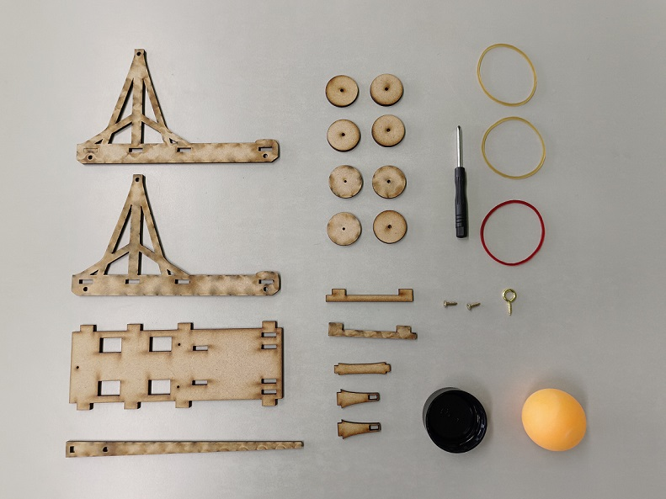

**三、活動過程 Activity Process**

1、利用密集板及相關零件(橡皮筋、鉤子、棉線)，組裝成一台投石器。

Assemble the catapult using the MDF board and related parts (rubber bands, hooks, cotton thread).

2、使用鉤子固定木棍位置後，把乒乓球放在瓶蓋上。

After securing the wooden stick with the hook, place the ping pong ball on the bottle cap.

3、將木棍旁的鉤子向下壓，手瞬間放開後，觀察投射距離是否有投進指定

的盒子。

**Press down the hook near the wooden stick, and after releasing it, observe whether the ball lands in the designated box.**

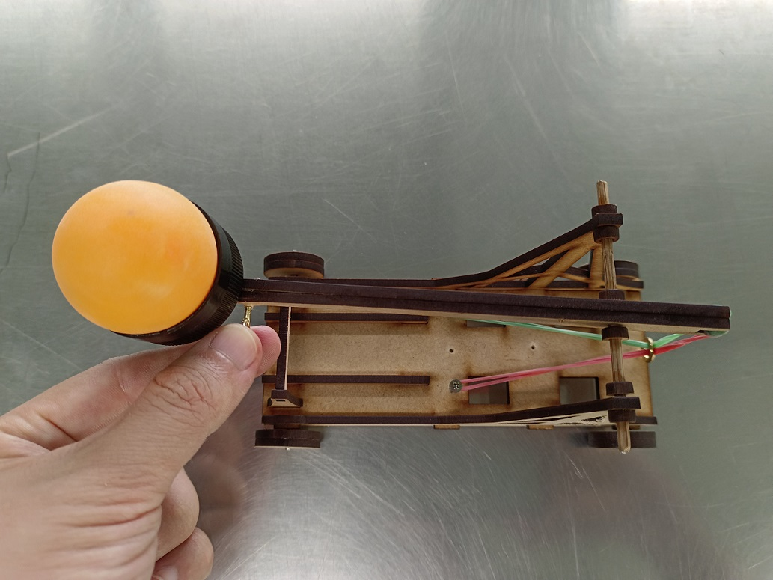

**四、科學原理**

1、槓桿原理 Leverage Principle：支點 Fulcrum(木棍前端與細小圓棍的交叉點The intersection of the front end of the wooden stick and the small round stick)、施力點 Effort point(木棍旁的鉤

子The hook next to the wooden stick

)、抗力點 Load point(乒乓球擺放位置 The position where the ping pong ball is placed

) 。

2、彈力 Elasticity：使用拉力拉長橡皮筋。

Using tension to stretch the rubber bands.

3、作用力與反作用力Action and Reaction：將拉長橡皮筋放開後產生的力。

The force generated when the stretched rubber bands are released.

**五、動動腦思考 Brainstorming**

1、瓶蓋放置在木棍的位置是否影響乒乓球所抵達的距離遠近？

Does the position of the bottle cap on the wooden stick affect the distance the ping pong ball reaches?

2、使用乒乓球當武器，木棍旁的鉤子向下壓，投射時是否有呈現拋物線的

弧度？

When using the ping pong ball as the projectile, does pressing down the hook next to the wooden stick result in a parabolic arc during the launch?